Contents

**JavaScript** 3

**Basics of JavaScript:-** 3

Console: - 3

Variables: - 4

Data Types in JavaScript: - 5

Type Conversion: - 9

The Math Object: - 11

String Methods: - 12

Template Literals: - 12

Arrays and it’s Method: 13

Object Literals: - 15

Date and Time: - 17

If-else and Comparison: - 17

Switches: - 18

Functions: - 19

Function Expression: - 19

PROPERTY METHODS: - 20

General Loops: - 21

Windows: - 23

Block Scope: - 25

DOM (Document Object Model): - 26

DOM Selector for single element: - 27

DOM Selector for Multiple element: - 28

Traversing the DOM: - 30

Create Element: - 32

Remove and Replace Element: - 33

Event Listener: - 35

Mouse Event: - 36

Keyboard and input event: - 37

Event Bubbling and Delegation: - 37

Local and Session storage: - 38

Constructors & the ‘this’ keyword: - 40

Build in Constructors: - 41

Prototypes: - 43

Prototypal Inheritance: - 46

Object.create: - 47

SubClasses: - 49

What is Asynchronous Programing: - 49

ASYNCRONOUS CODE: - 50

AJAX & XHR introduction: - 51

XHR Object Method and working with test: - 54

Working with Ajsax and JSON: - 56

Data from external API-Chunk Norris Project: - 59

REST API and HTTP Request: - 61

Callback function: - 63

ASYNCHRONOUS EXAMPLE: 63

ES6 Promises: - 64

Fetch API: - 66

Arrow Function: - 73

Custom HTTP Library(Fetch with Promises)- Part 3: - 74

Async & Await- ES7 Feature: - 77

Error Handling with Try Catch: - 80

Regular Expression: - 81

Form Validation with Regular Expression: - 84

Iterators and Generators: - 85

Symbols(Primitive Data type) in ES6: - 87

Destructuring: - 87

Map: - 89

SET: - 91

JavaScript Patterns: - 93

Module and Revealing Module Pattern: - 93

Singleton Pattern: - 95

Factory Pattern: - 95

Observer Pattern: - 97

Mediator Pattern: - 103

State Pattern: - 105

ES2015 Modules: - 110

# **JavaScript**

## **Basics of JavaScript:-**

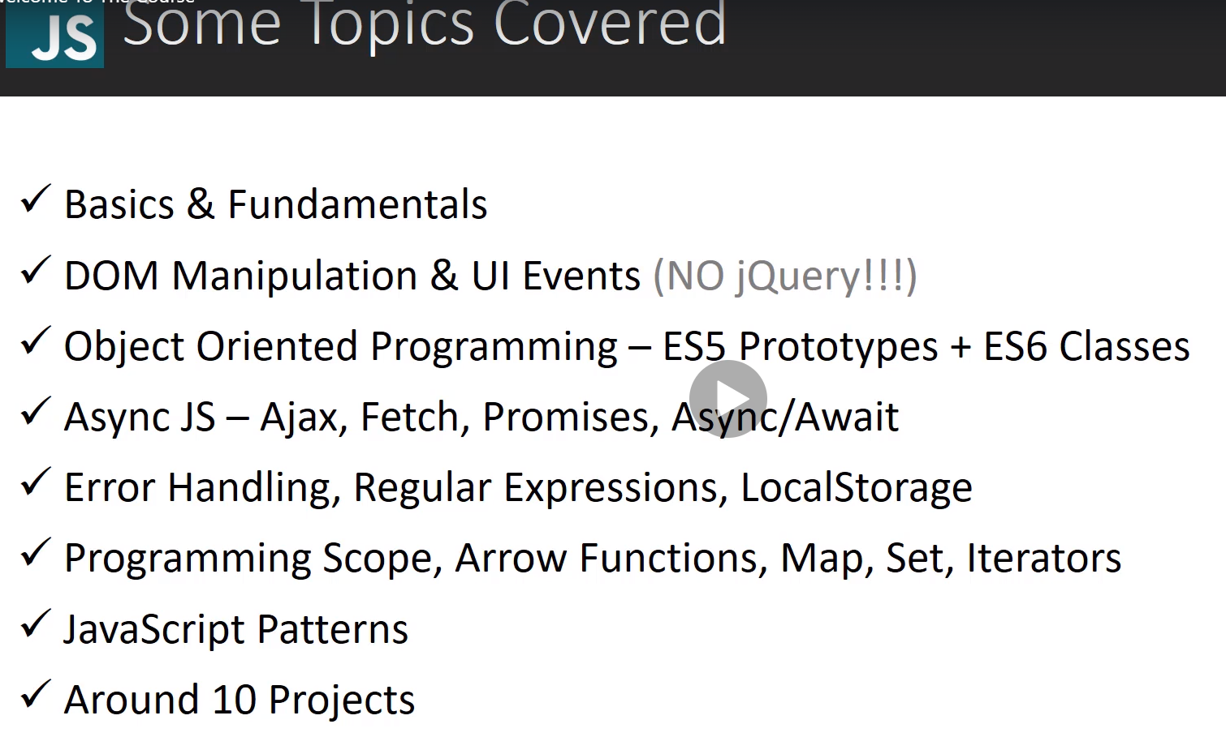

### Console: -

Console.log (‘Hello ‘) // to log the value in console

Console.table({a:1, b:2}) // prints the value in console in tabular format having two column index and value. Index will be key and value will be value that we are giving during object creation like 1 and 2 here.

Console.error(‘this is some error’) // print error value in console in red

Console.clear(); // to clear the console

Console.warn(‘this is a waring’)// can see warning in console in yellow color

Console.time(‘hello’); console.timeEnd(‘hello’); // use to show the timing taken by the javascript to execute the script/code that has been written between console.time and console.timeEnd. **Note: - Important point need to be noted is the argument of time and timeEnd should be same always to get expected output.**

### Variables: -

3 types of variable (Var, const and let) we have in JavaScript.

Var and let variable can be reassign to another value but const is like a constant. Once we declare cannot be changed.

If we do not assign any value in the variable while declaring, then it’s value will be undefined. But can be re-assign latter.

It is mandatory to initialize cons variable while declaring itself. Can be declare one place and initialize another place, it gives error.

Below scenario is valid. Because we are not reassigning person object but changing their data value inside object i.e. name, and similarly we can update array also.

We can change arrays and object that are assigned to variables using const but cannot re-declare and assign new array or object.

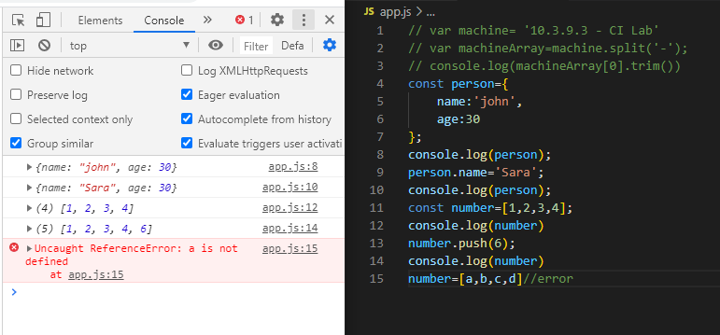

let is similar to var but it allows you to declare variables that are limited to the scope of a block statement, or expression on which it is used, unlike the var keyword, which defines a variable globally, or locally to an entire function regardless of block scope.

### Data Types in JavaScript: -

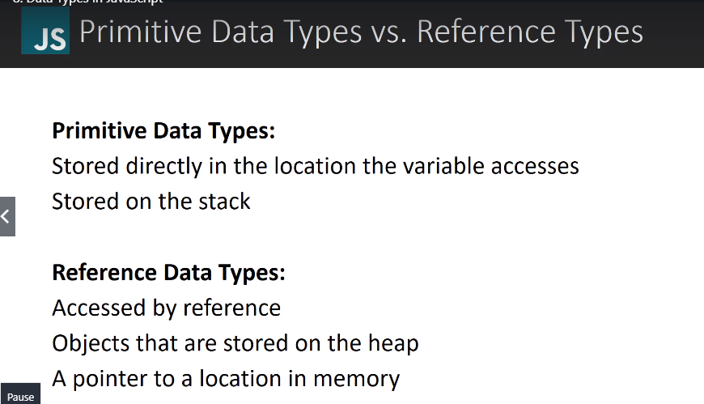

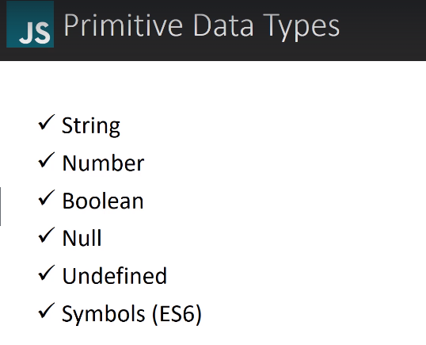

**Note: -** In JavaScript decimal, float, int all considered as Number.

Null is intentional empty value; we must assign null in the variable to make it null. Undefined is a variable which has not assigned any value during declaration. By default, all variables are undefined.

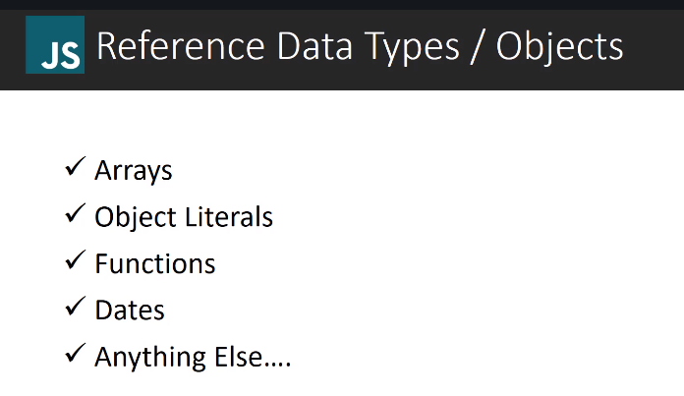

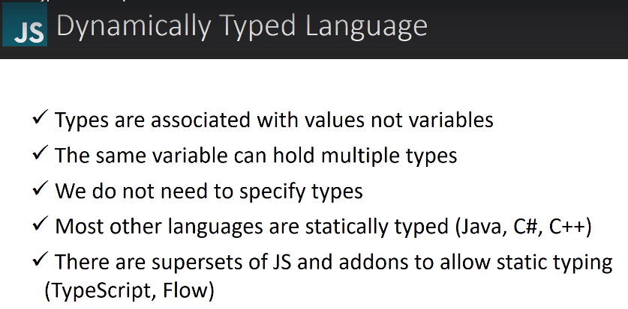

**Note: -** typeof operator tells the data type of variable

**Note: - Null is a primitive data type but typeof operator shows null as an object because it’s a kind of bug in JavaScript.**

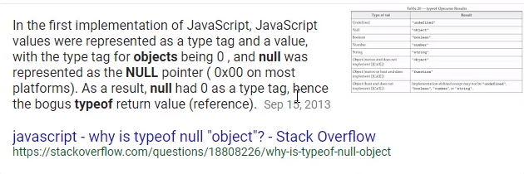

**Symbol** is a new data type added as a part of ES6.

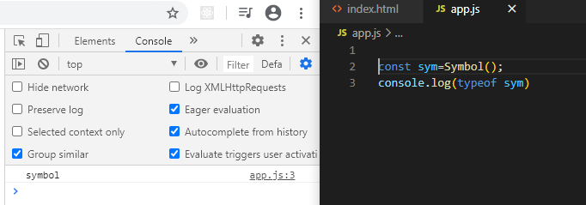

All reference data type like array, object, Date etc. will show as an Object in typeof operator.

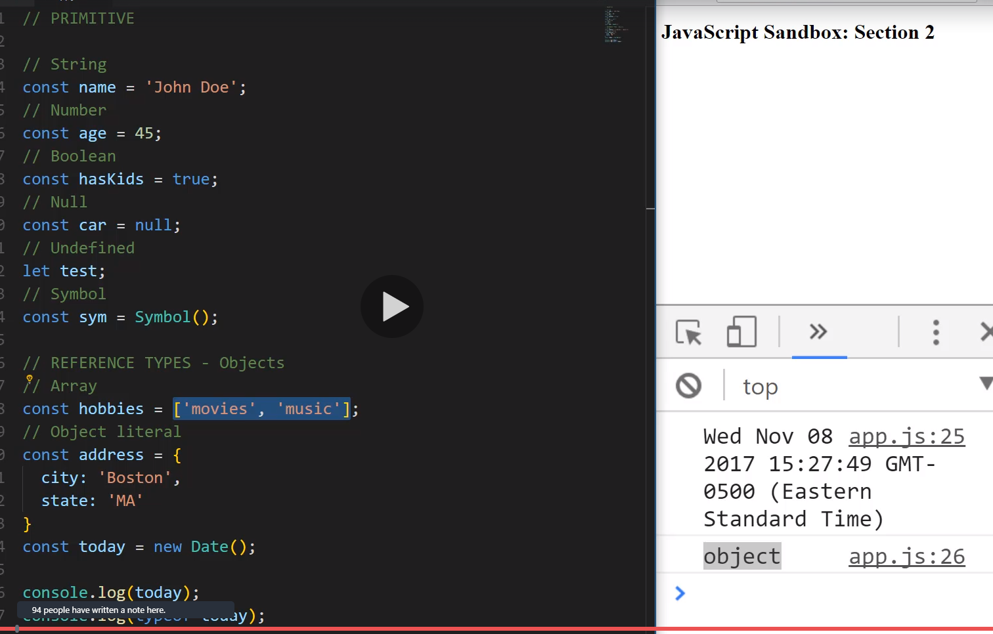

### Type Conversion: -

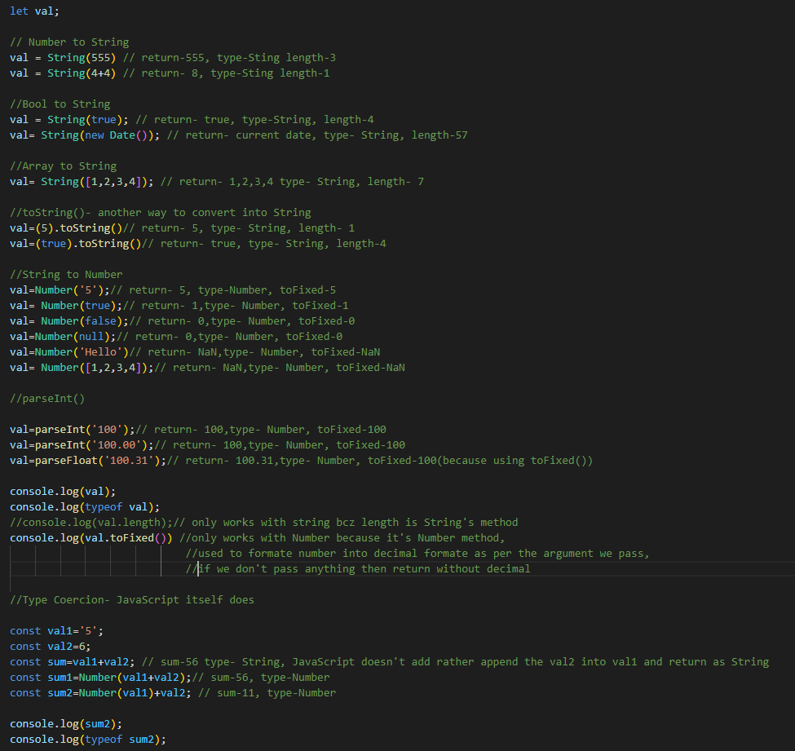

### The Math Object: -

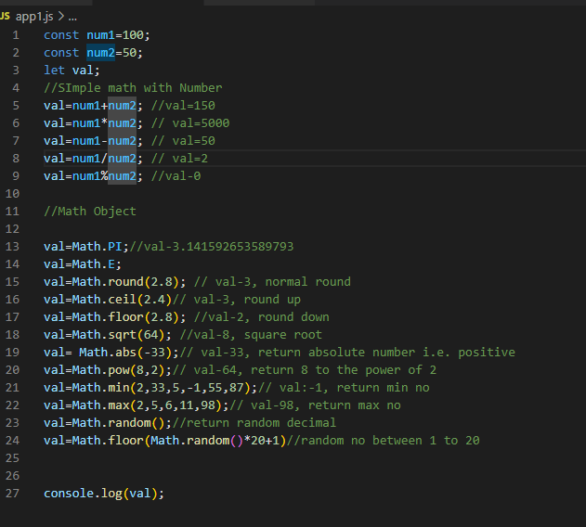

### String Methods: -

There are 3 methods for extracting a part of a string:

* slice(*start*, *end*)
* substring(*start*, *end*)
* substr(*start*, *length*)

slice() extracts a part of a string and returns the extracted part in a new string.

The method takes 2 parameters: the start position, and the end position (end not included).

substring() is similar to slice().

The difference is that substring() cannot accept negative indexes.

substr() is similar to slice().

The difference is that the second parameter specifies the **length** of the extracted part.

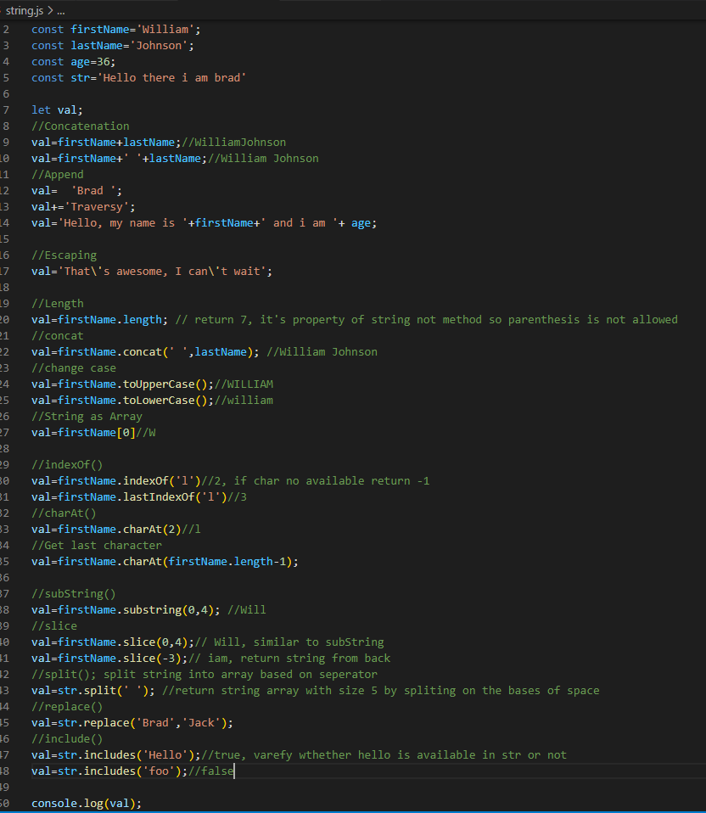

### Template Literals: -

Template literals are string literals allowing embedded expressions. You can use multi-line strings and string interpolation features with them. They were called "template strings" in prior editions of the ES2015 specification

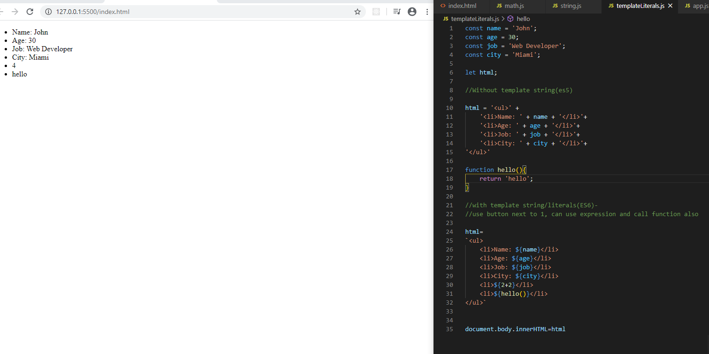

### Arrays and it’s Method:

Arrays allows to store multiple values in one variable. They can be mutated and iterated through and can be used in some complex algo.

The splice() method can be used to add new items to an array. The first parameter defines the position where new elements should be added (spliced in).The second parameter defines how many elements should be removed. The splice() method returns an array with the deleted items. With clever parameter setting, you can use splice() to remove elements without leaving "holes" in the array.

The slice() method slices out a piece of an array into a new array. The slice() method creates a new array. It does not remove any elements from the source array. The slice() method can take two arguments like slice(1, 3).

The method then selects elements from the start argument, and up to (but not including) the end argument.

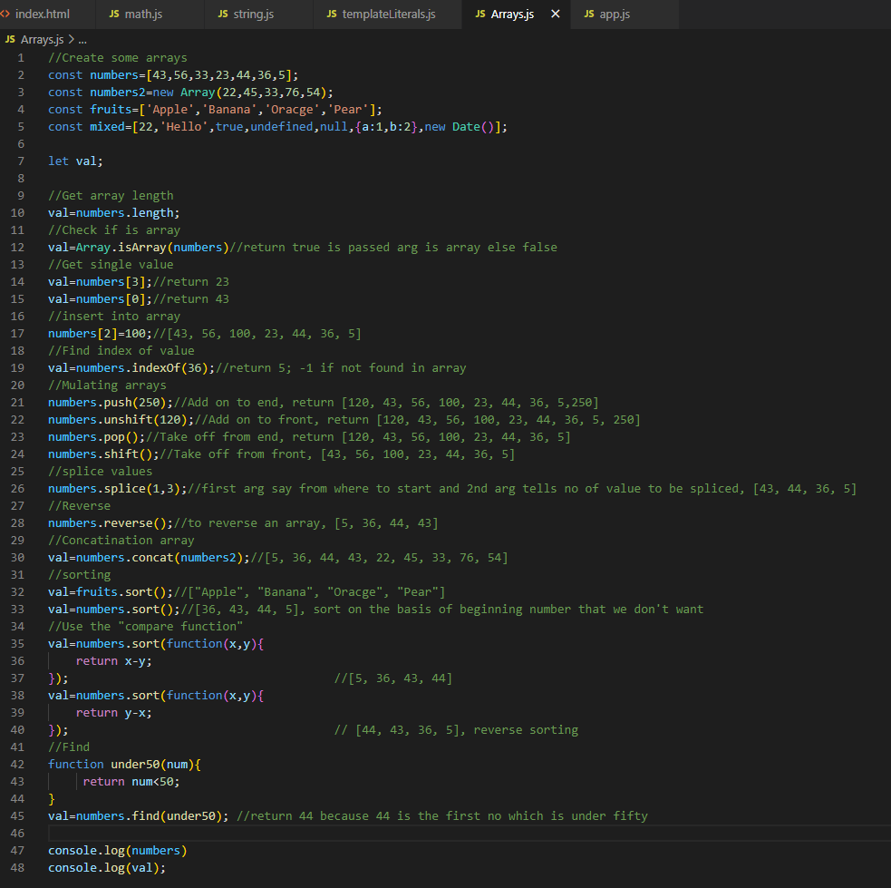

### Object Literals: -

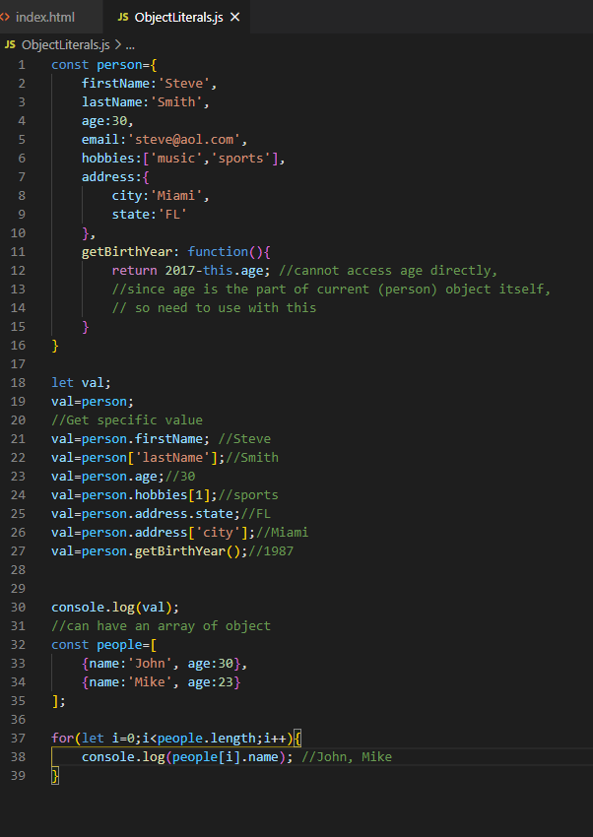

### Date and Time: -

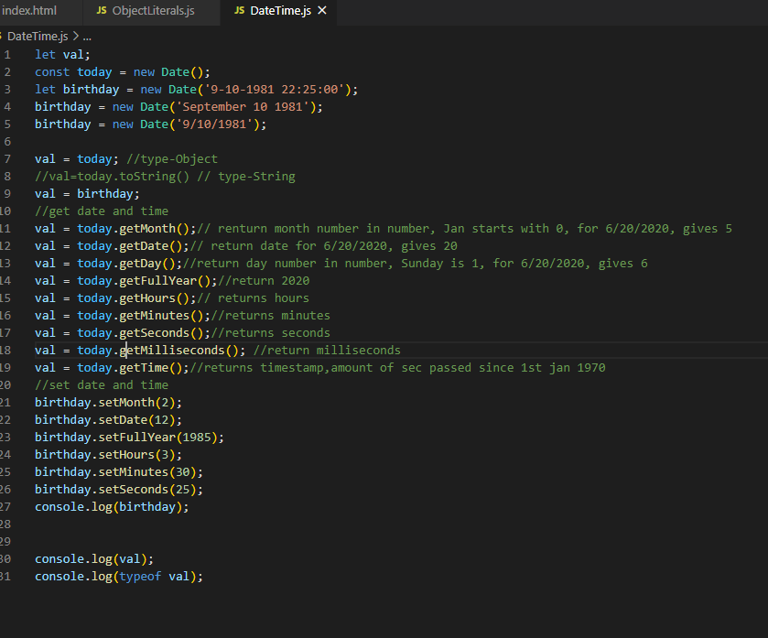

Ref: - <https://developer.mozilla.org/en-US/docs/Web/JavaScript/Reference/Global_Objects/Date>

### If-else and Comparison: -

‘=’: Assignment operator

‘==’: comparison operator without type

‘===’: comparison operator with type

‘!=’: comparison operator, not equal to without type

‘!==’: comparison operator, not equal to with type

**Note: -**To verify that some variable is defined or not we can use if condition like

If(id){ Console.log(`Id is available’`)}

Else{‘id is not available’}

But our code will give error if it falls in else condition and id is not defined. So, the best way to verify it is by using typeof Operator like.

If(typeof id !== ‘undefined’){

Console.log(`id is available`)

}

Else{

Console.log(‘id is unavailable’)

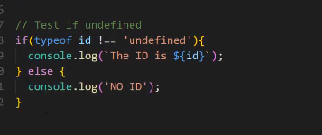

### Switches: -

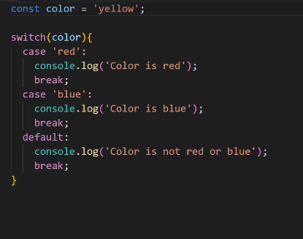

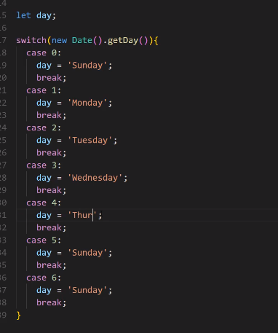

## Functions: -

Functions are blocks of code that can be defined and then called at a later time or in some cases defined and called at the same time.

If function have some parameter and we are not passing anything during function call and trying to access the argument inside function definition, then argument value will be **undefined**.

There are two ways to have a default value of parameter, if user does not pass args then function takes the default arguments otherwise override the passes argument.

1. using If statement and check the arguments by typeof operator , if it is undefined; the assign default value.

2. Assign default value in parameter itself.

### Function Expression: -

Function expression is putting a function as a variable assignment. Function can be named or anonymous. We can also have default argument in function expression.

IMMEDIATELY INVOCABLE FUNCTION EXPRESSIONS – IIFEs: -

It is a function that we have declare and run at the same time. To write this we need to have an expression and we can make an expression by putting it into parenthesis. Define an anonymous function inside parenthesis and to call it just we need to add parenthesis which can have with or without argument.

IIFEs are very useful in modular design pattern

### PROPERTY METHODS: -

We can have a method as a property of an object also. When a function is put inside an object it is called a method. We can also define function outside for the object.

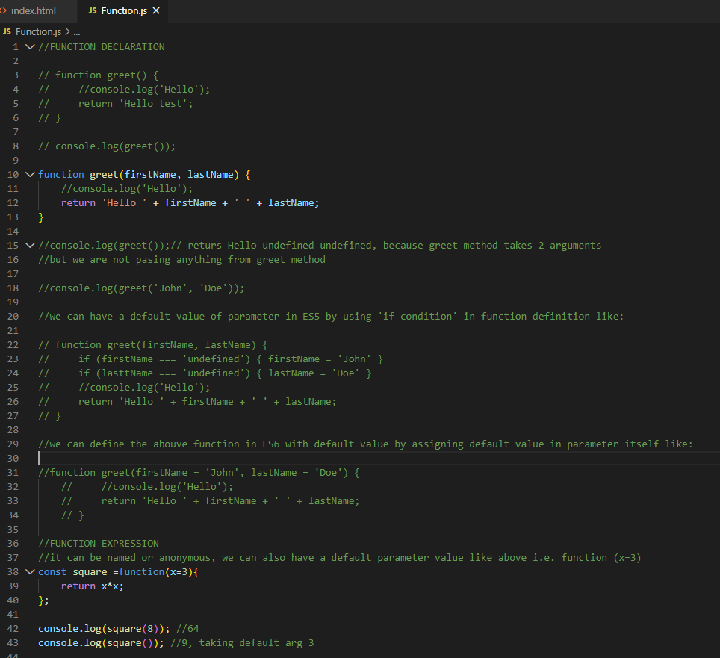

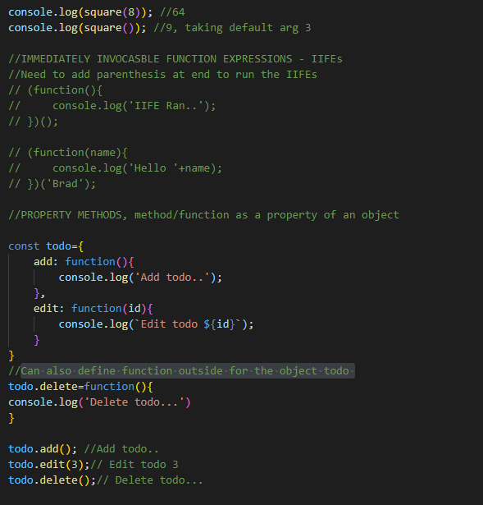

### General Loops: -

Loops is an iteration which repeats until it reaches to the specific condition.

1) For Loop

2) While Loop  
3) Do while loop

4) Loop through array

5) For each loop

6) Loop through Map

7) For In loop

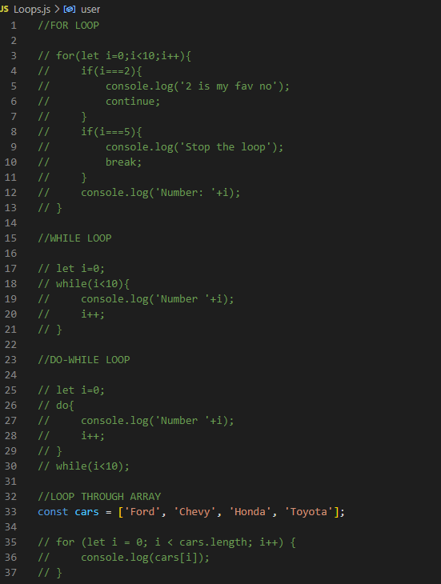

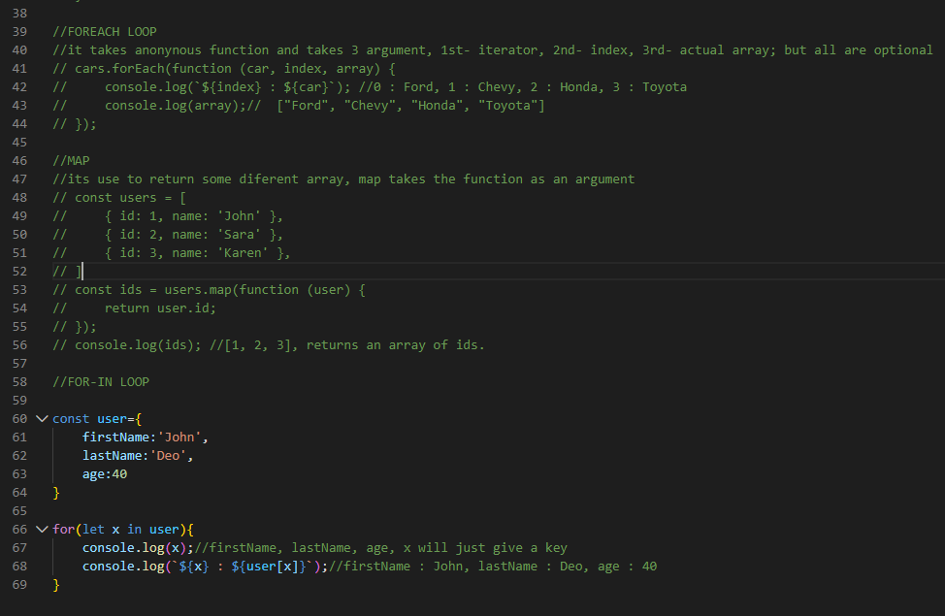

## Windows: -

Window or the browser is a global object in client side JavaScript.

Fetch Api is used to make HTTP request.

The difference between replace() and assign() method of location is that replace() removes the URL of the current document from the document history, meaning that it is not possible to use the "back" button to navigate back to the original document.

Use the assign() method if you want to load a new document, and the option to navigate back to the original document.

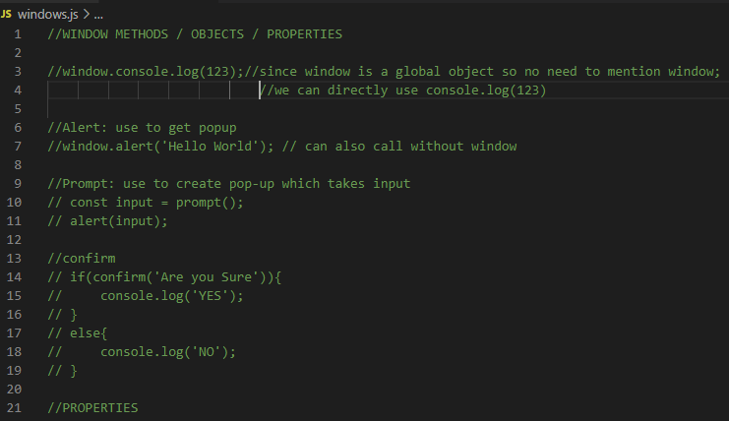

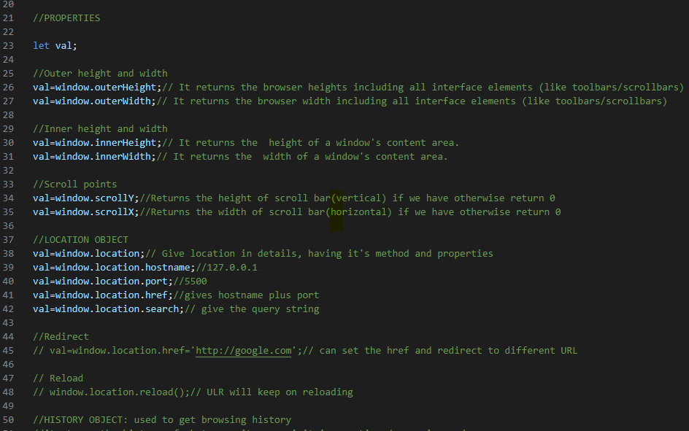

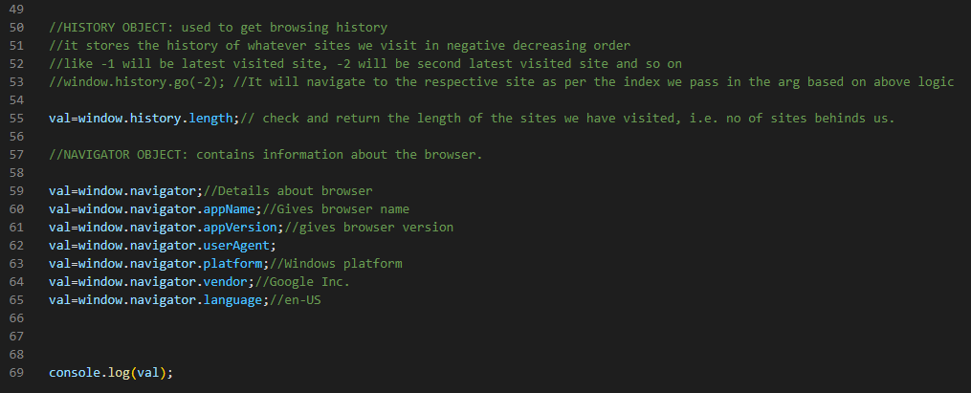

## Block Scope: -

block scope overrides var type of global variable but let and const cannot be override.

Block level variable has capability to override global variable having var type.

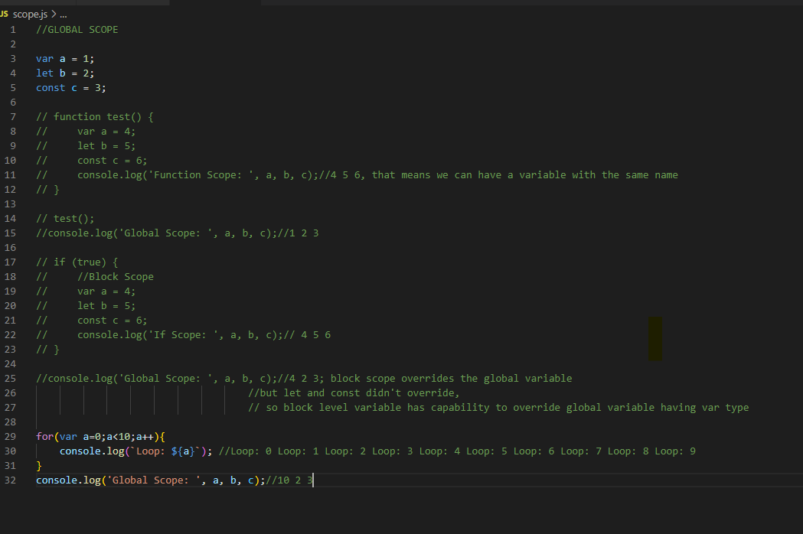

Let and const have block level scope and var has function scope.

## DOM (Document Object Model): -

It is a structural representation of HTML document. It is a kind of tree of nodes or elements created by the browser. We can use JavaScript to manipulate these DOM elements or nodes.

DOM is object oriented means each node has its own set of properties and methods that we can change, add, or remove.

Browser gives us windows object and inside that we have document object.

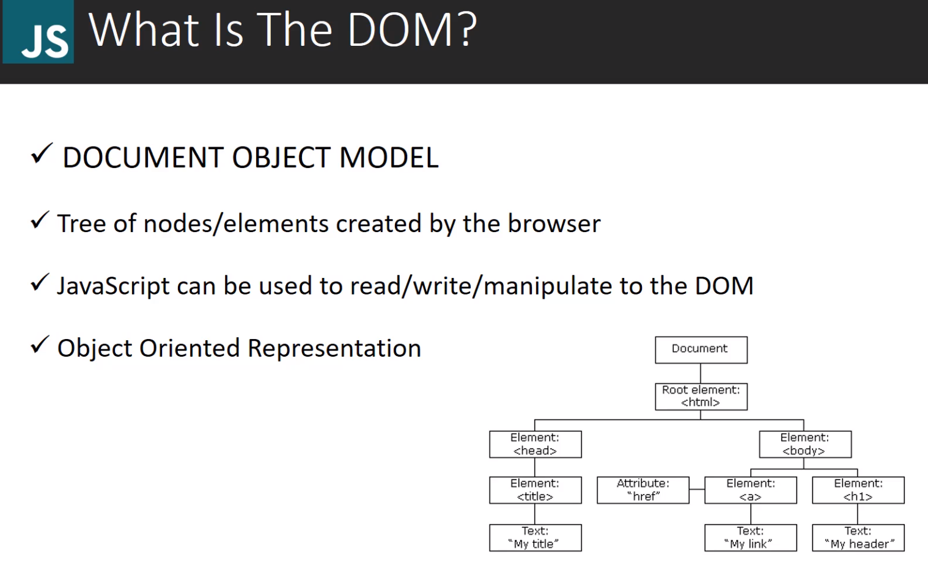

**Document Object: -**

Document is the child object of window.

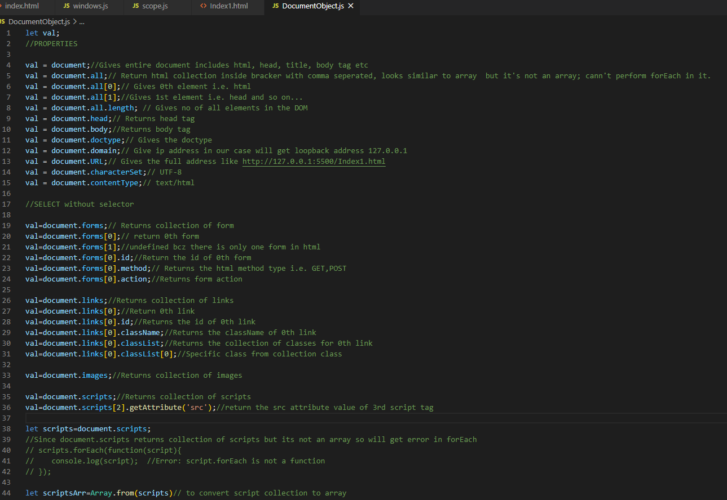

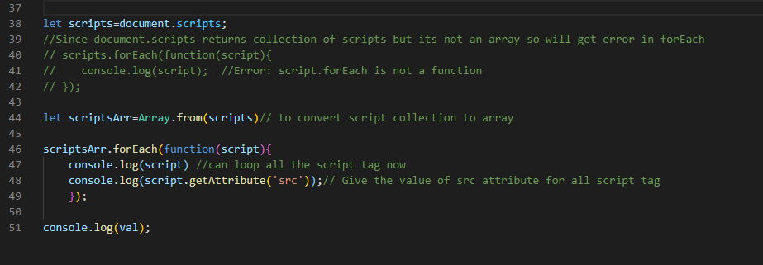

### DOM Selector for single element: -

In Js we have couple of different selectors that can be categorized into two different types:

1) Single element- It allows to grab one element by its ID, class etc. and stores only one thing. So, if we use single element selector on the class that appears more than once in the DOM then it’s just going to grab first single one.

2) Multiple element- Multiple elements selectors will actually get all the element of that class and then return in HTML collection or a node list depending on which selector we use. Like we have seen the example above where we were selecting items directly using document properties (forms, links).

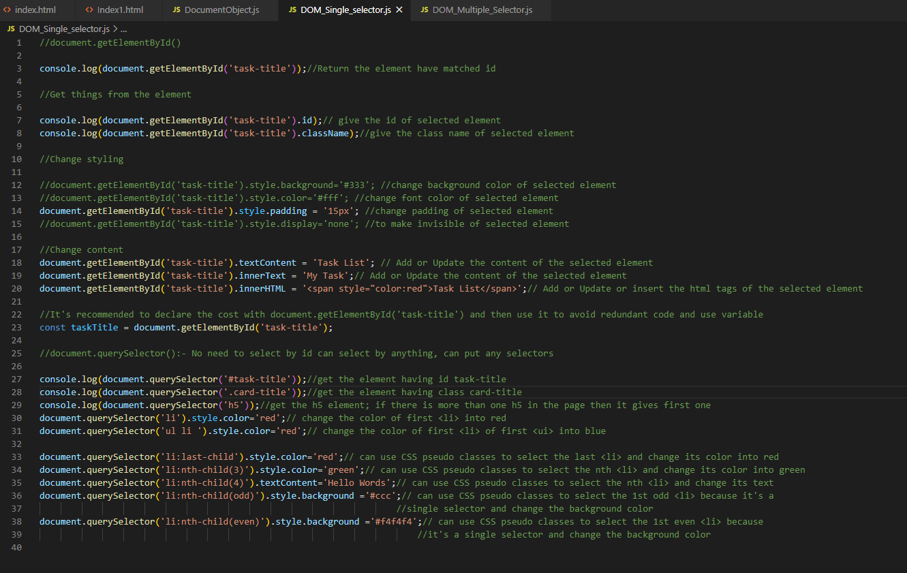

### DOM Selector for Multiple element: -

Multiple selector selects multiple element and return either collection or a node list, both are similar to array except there certain thing we can’t do with a regular array but they can be converted into arrays very easily.

Document.getElementsByClassName- Used to select multiple element by class name and it returns in the form of HTML Collection which need to convert into array if we want to perform any array operation.

But length and access through index is allowed in this also.

Document.getElementByTagName- Used to select multiple element by tag name and it returns in the form of HTML Collection which need to convert into array if we want to perform any array operation.

But length and access through index is allowed in this also.

Document.querySelectorAll- Used to select multiple element and returns in the form of NodeList.

All array operation can be performed on the NodeList.

**Note:** querySelectorAll is not a JavaScript API but it is a browser API.

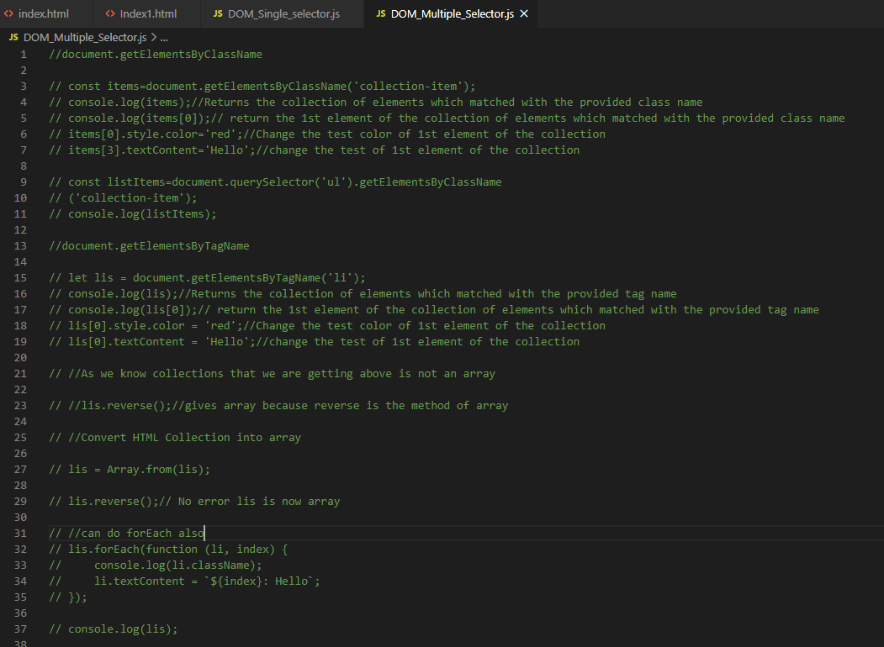

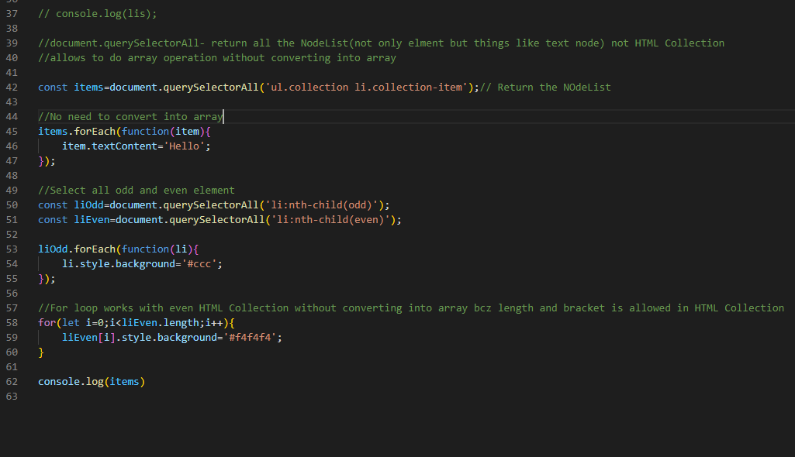

### Traversing the DOM: -

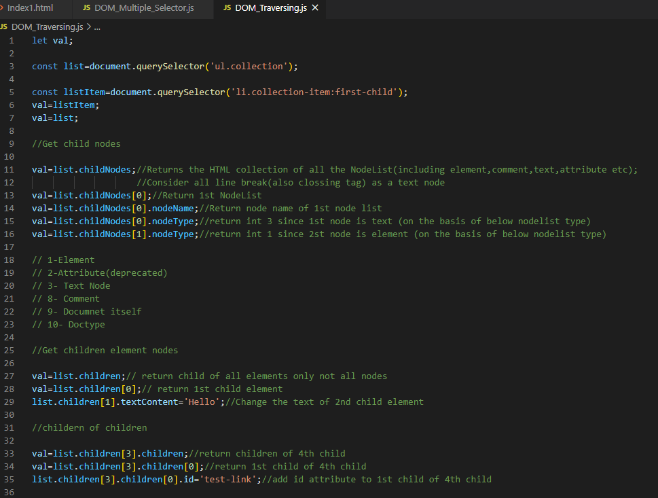

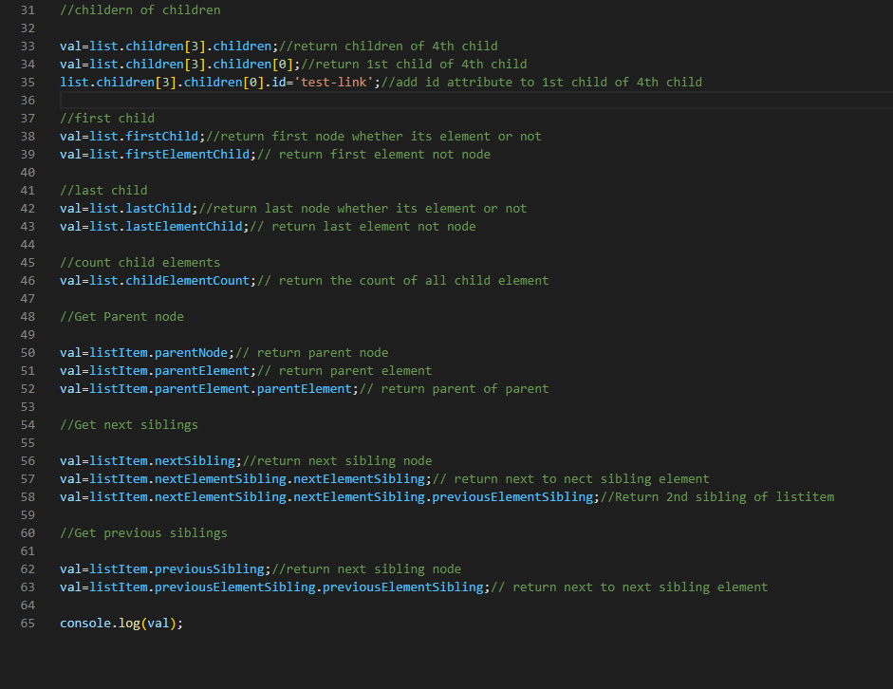

### Create Element: -

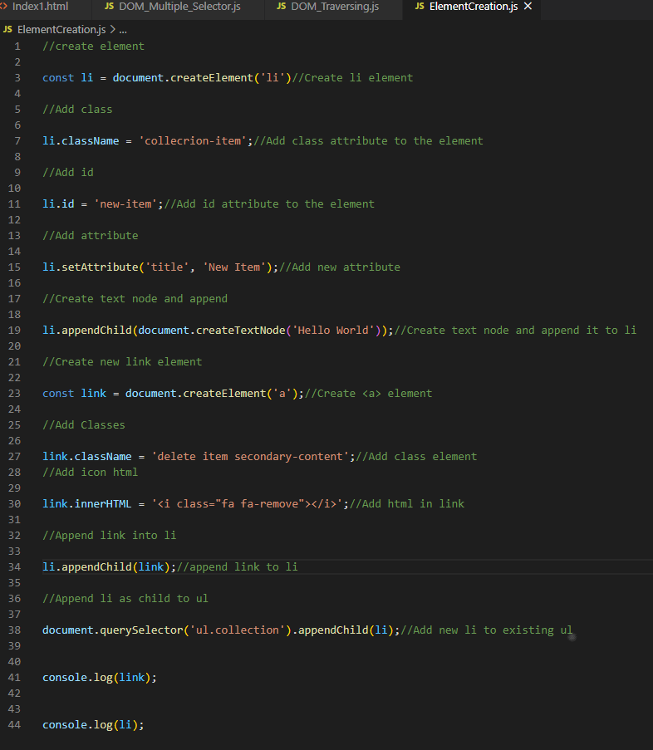

### Remove and Replace Element: -

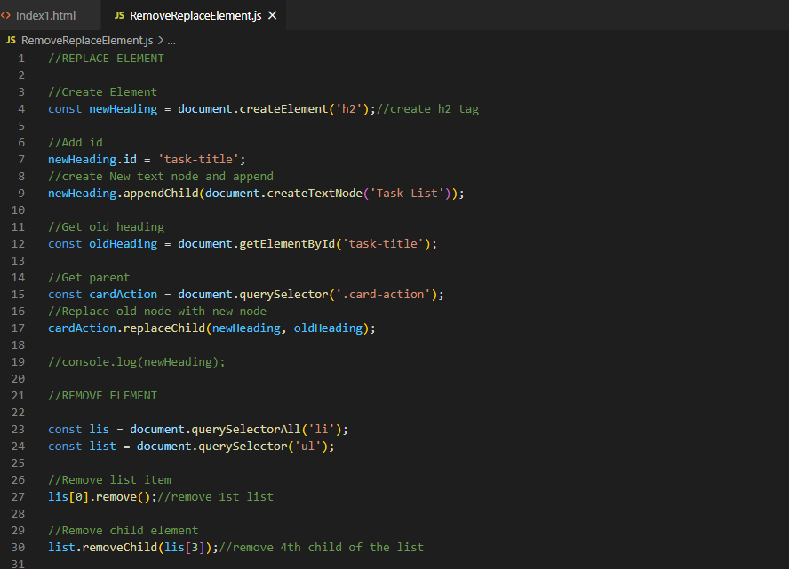

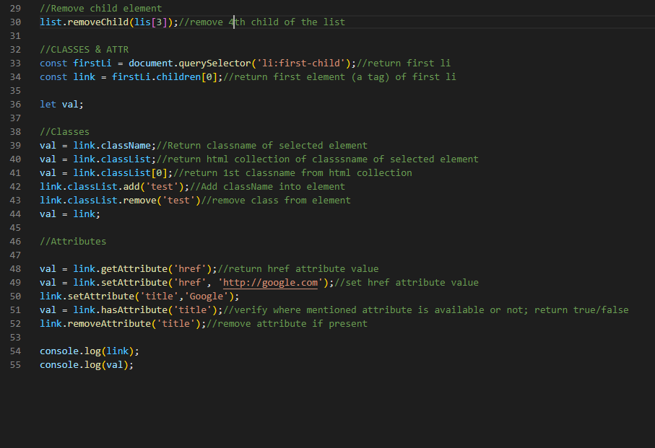

## Event Listener: -

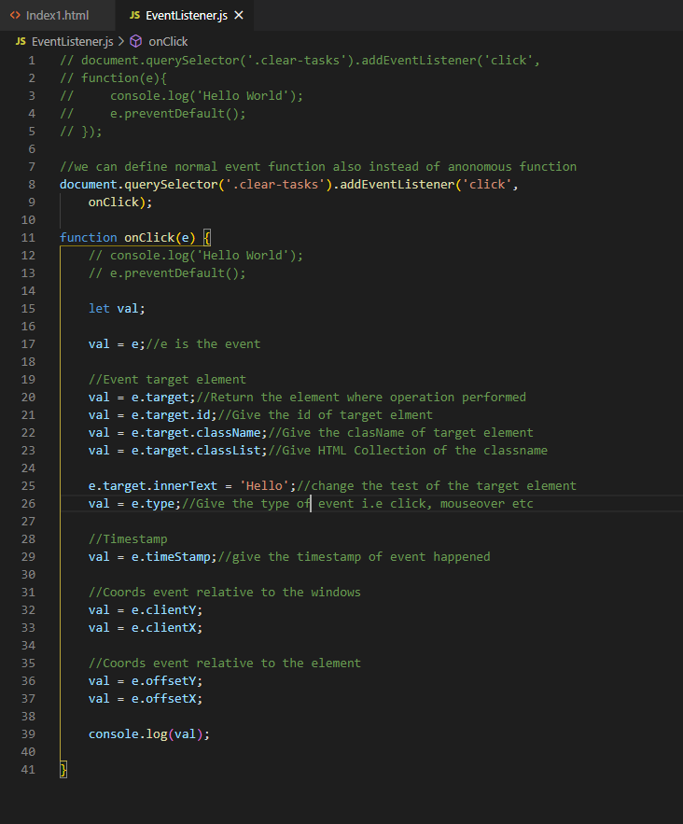

### Mouse Event: -

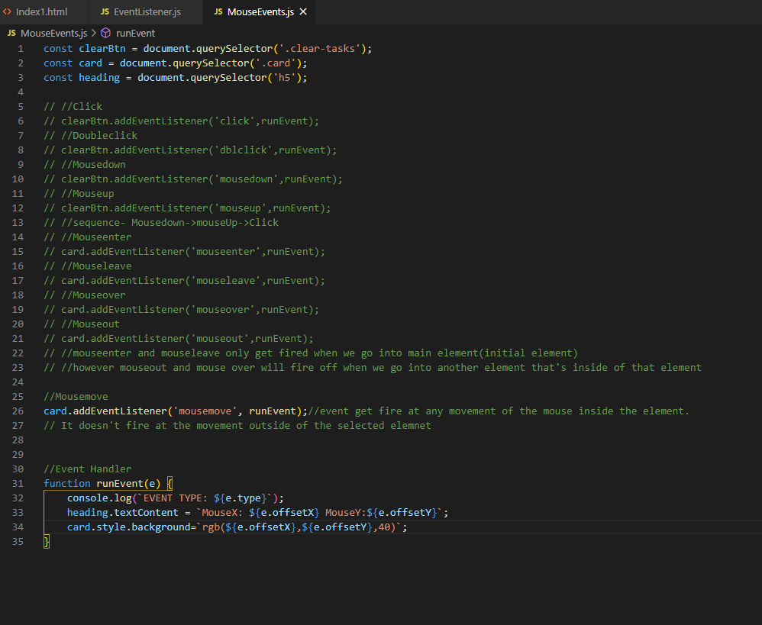

### Keyboard and input event: -

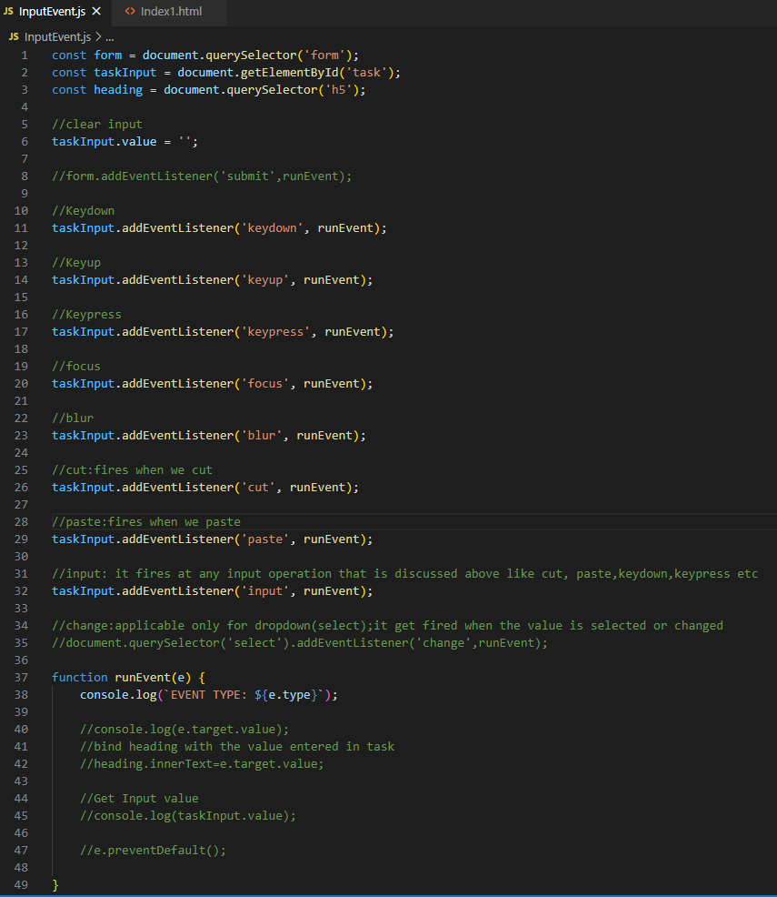

### Event Bubbling and Delegation: -

Event bubbling is bubbling up of the events through the DOM. So, when events happen on a particular element in the DOM and actually will bubble up through its parent.

Event Delegation is an opposite of event bubbling where we put the listener on one of the parent element and then we use logic inside of the event handler to target the element that we actually want that click for the whatever type of event it is. So, event will go from parent their children.

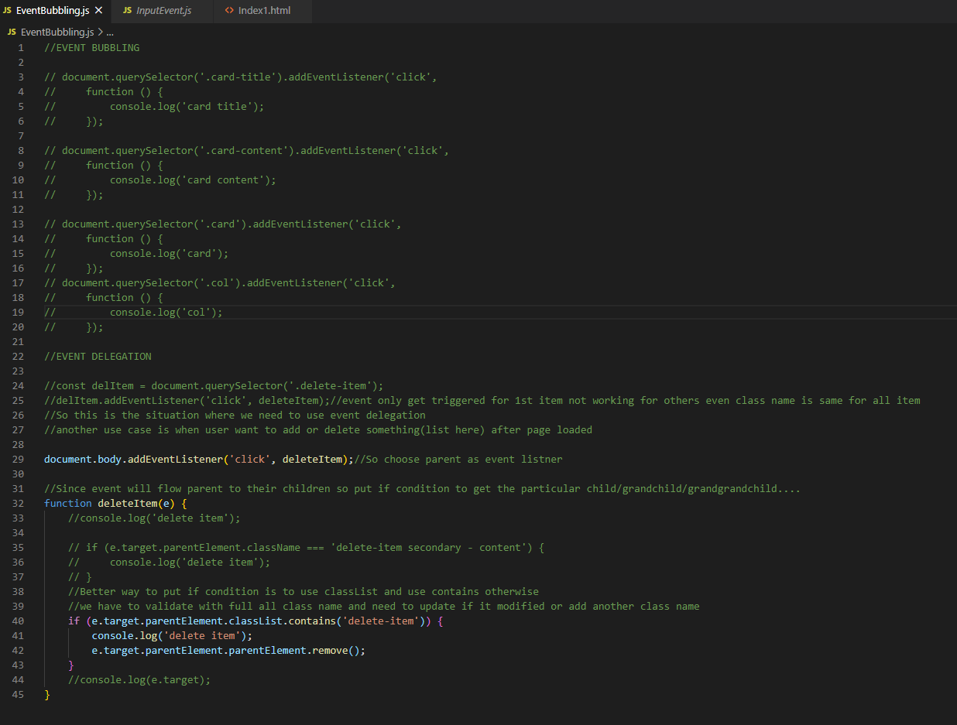

## Local and Session storage: -

Always store value as string; could be array but in string format only.

Local storage will stay until we manually clear it out in our setting or through our program and session storage will delete once browser is closed or session ends.

Localstorage and sessionstorage is an object of global object window.

Imp point to be noted is in storage always save value in string format but in most of the cases we use object (like model class of POJO) to get and set the property value, so we use parse and stringify method of JSON to convert object into string and vice-versa.

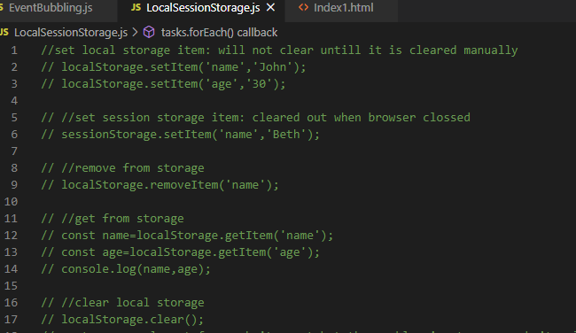

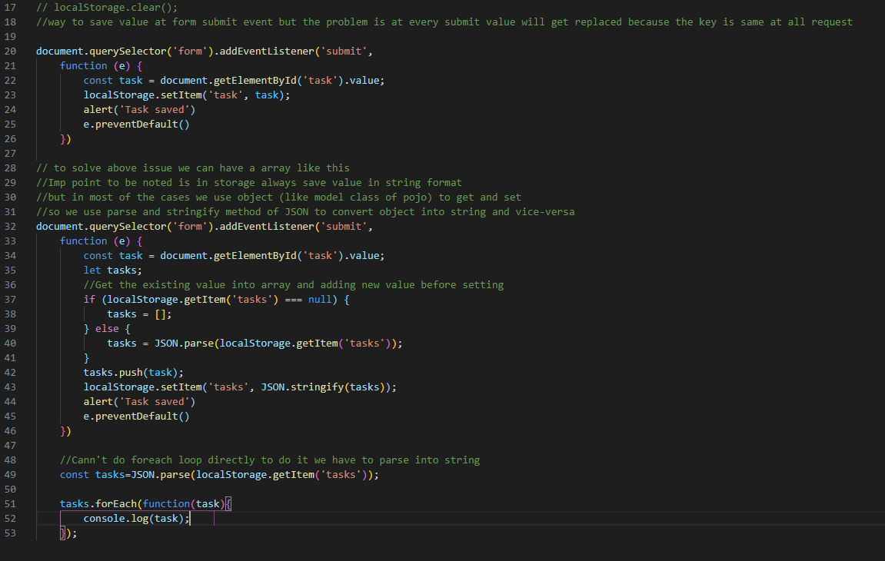

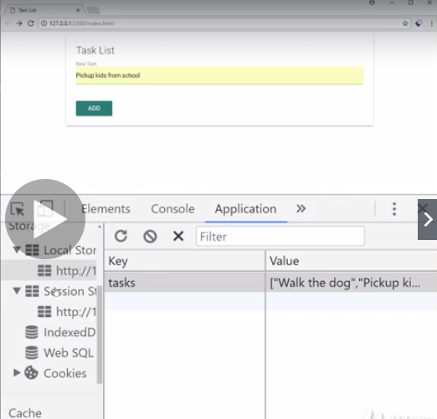

## Constructors & the ‘this’ keyword: -

Generally, constructor name starts with capital letter.

‘new’ keyword is used to create object.

‘this’ keyword refers to the current instance of the object.

If we log ‘this’ outside any function, then it refers to the window object because by default windows is the global object and this always refer to the current object which is window.

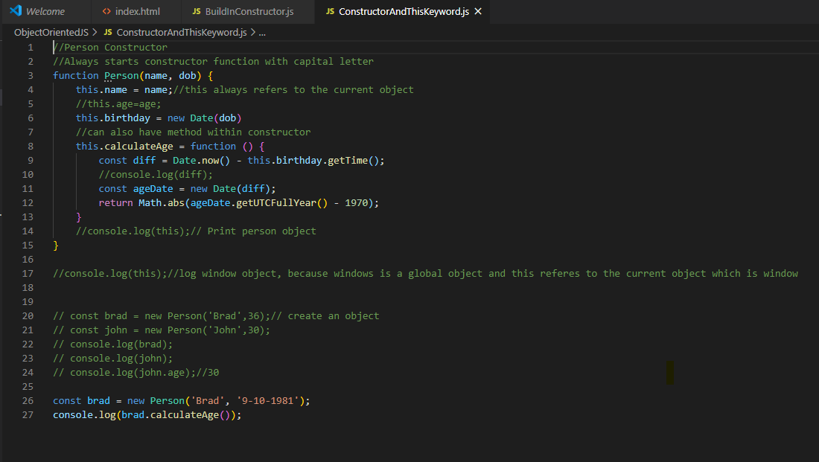

## Build in Constructors: -

There are many core objects have constructor in JavaScript but most of them are not advisable to use for instance primitive type like string, number, Boolean can actually be created as object instead of primitives and can do this by using certain constructors like String and Number and so on. But it’s not recommended to do this because it slows down execution speed. It’s more code and confusing and can have issue when using triple equals operator and trying to compare the value to know the value and the type.

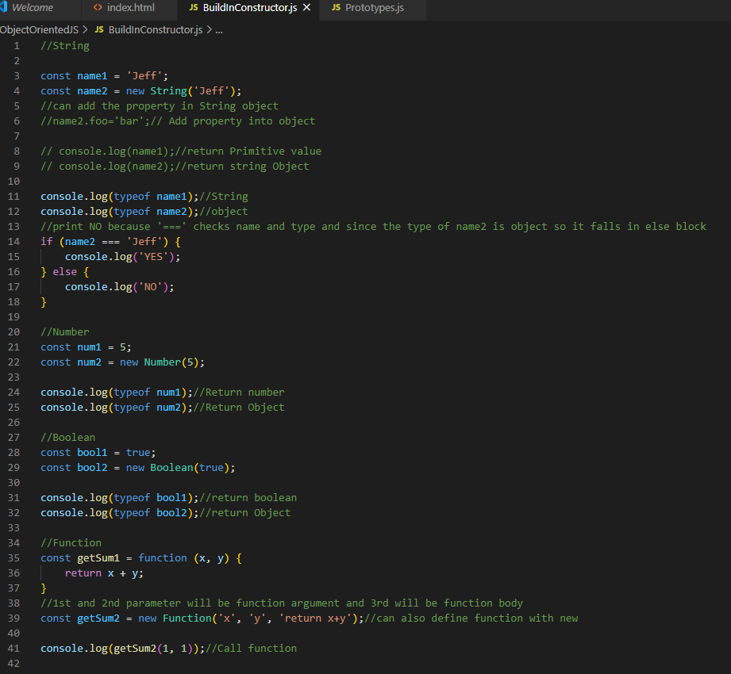

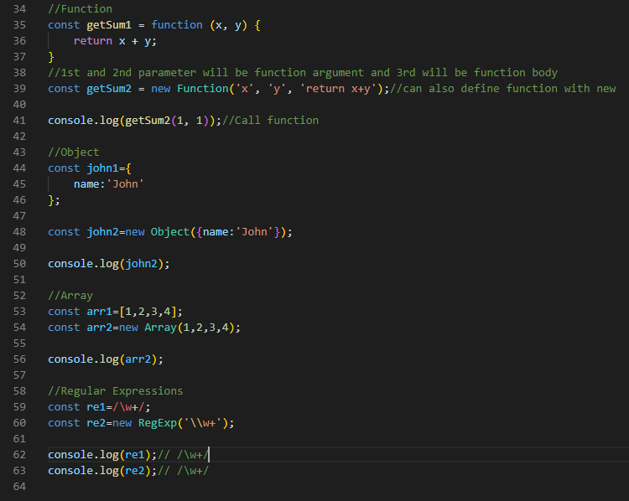

## Prototypes: -

Each object in JavaScript has a prototype and a prototype is an object itself. All objects inherit their properties and methods from their prototype.

When we are dealing with object literals then we are dealing from a prototype called “Object.prototype” .

And when we are dealing with the object that were created through a constructor like for instance the person constructor, we created; it is going to come from “person.prototype”.

There is something called prototype chain where we can go up from “person.prototype” to “object.prototype”.

Browser gives pseudo property, or this pointer called “__proto__” and it represents user defined prototype . and we have another pseudo property inside user defined prototype, this represents object prototype which is kind of the top of the chain.

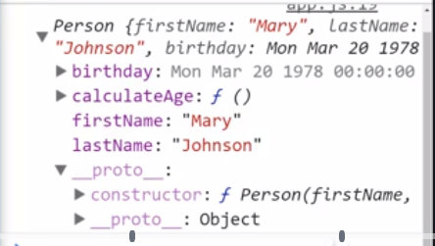

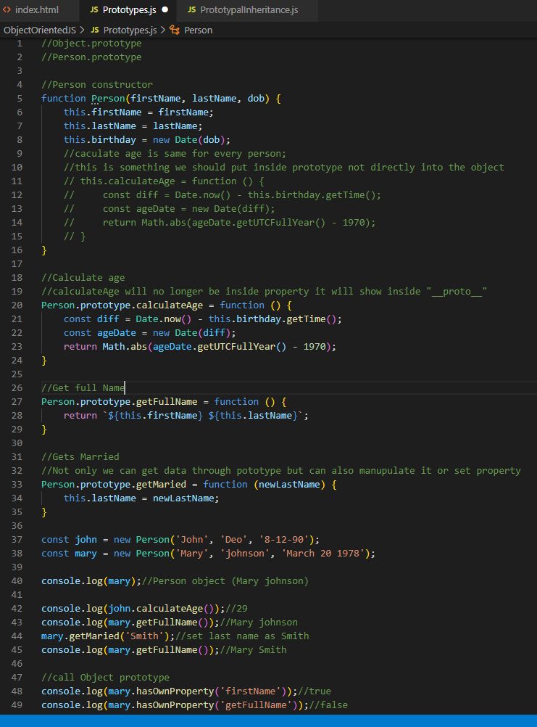

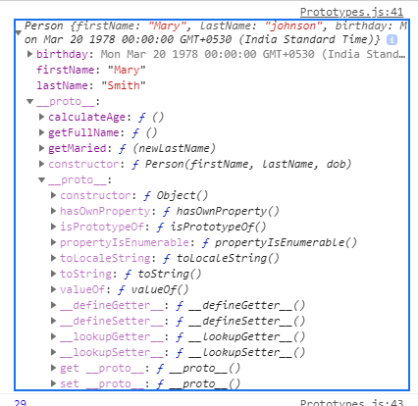

## Prototypal Inheritance: -

We can have one object and another object can inherit its prototype. Like customer object can inherit the Person’s object prototype.

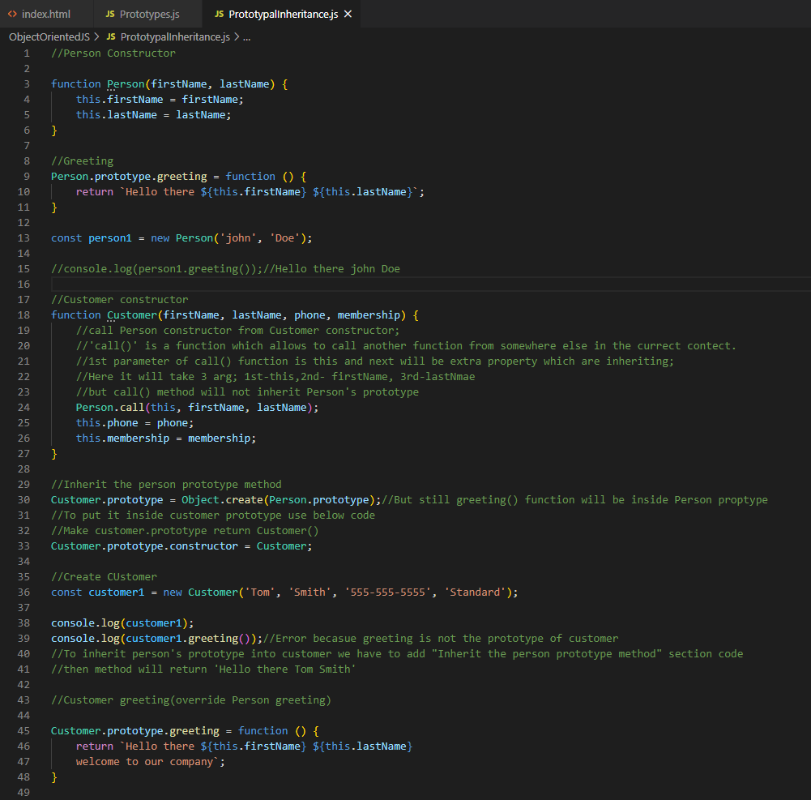

## Object.create: -

Another way to create object in ES5 is by using object.create() method.

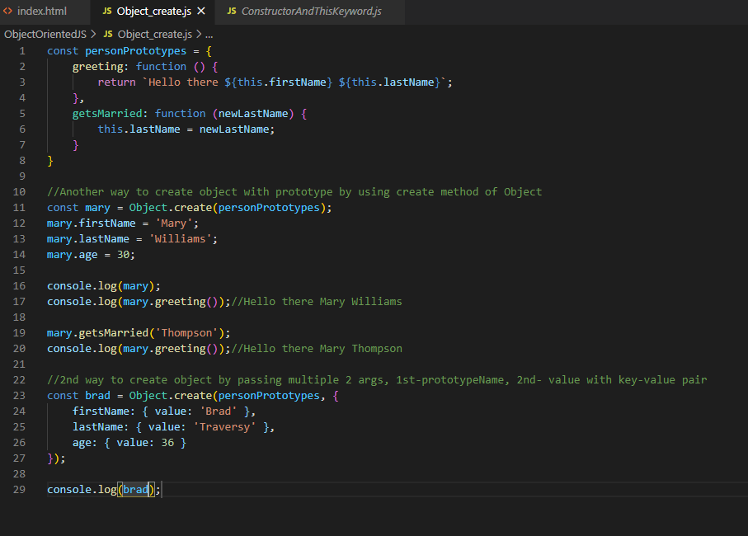

**ES6 Classes: -**

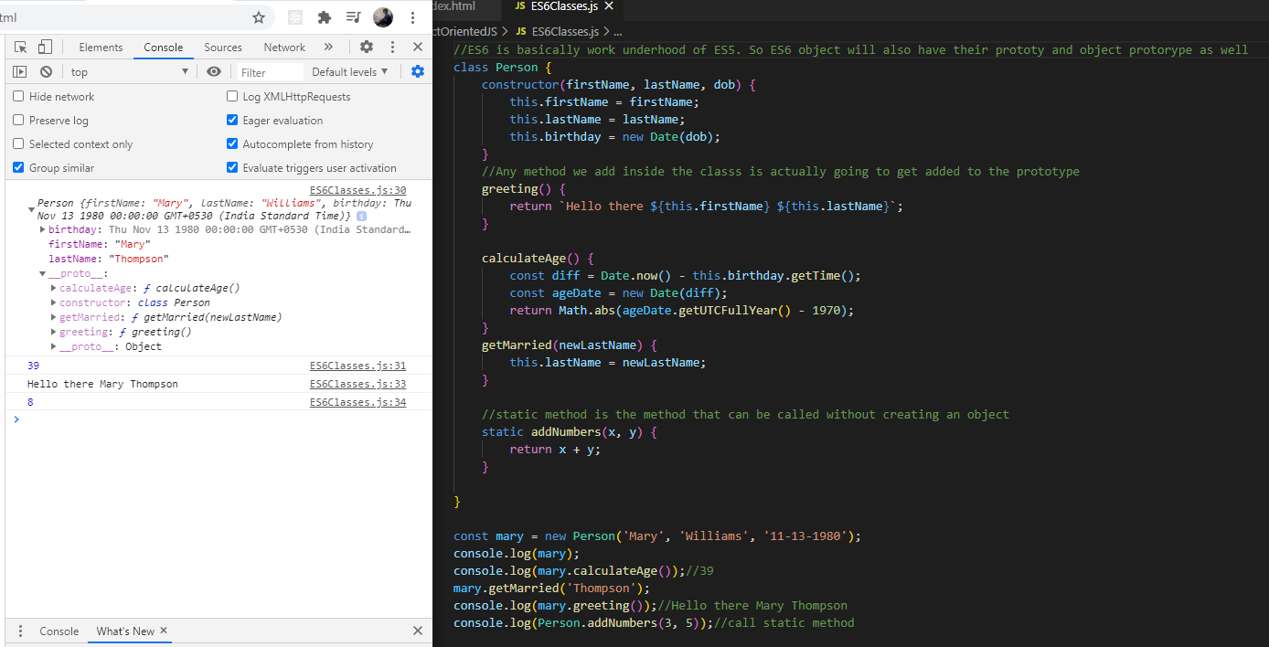

## SubClasses: -

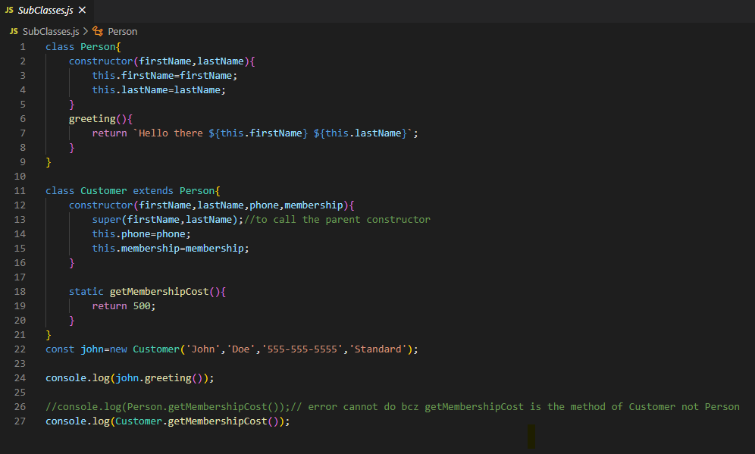

## What is Asynchronous Programing: -

Technologies like Ajax and Fetch API which are used to make HTTP requests to files API and services whether our own or external rest API.

Ajax is the XML HTTP request object is the older technology but very reliable and fetches a newer standard and we are going to be working with both.

SYNCHRONOUS CODE: It’s a way of writing the code where we are going to have to wait until the HTTP request returns or complete their execution. And only after we can move on to the next function. This is what called blocking code . It’s going to block until the HTTP requests continues their execution which obviously slows things down.

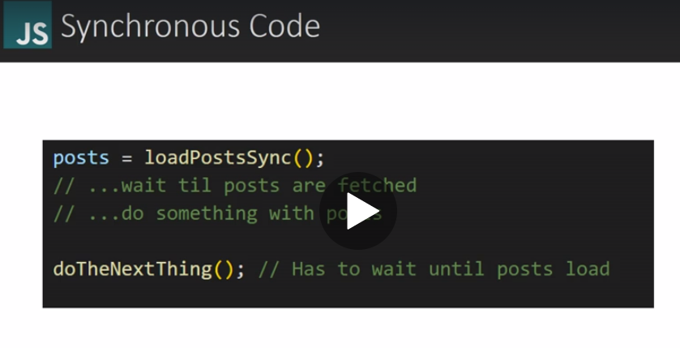

### ASYNCRONOUS CODE: -

In Asynchronous case instead of just pulling the post out of a synchronous function we are passing in a callback function which is just one method for handing a synchronous code. This callback will run and fetch the post and allow us to do something with the post. But to do the next thing function does not have to wait until the posts are fetched and loaded. So, the program isn’t block and it will simply just keep going even if it takes a while for the post to be fetched. It is not going to stop the do the next thing function from running. It is much faster.

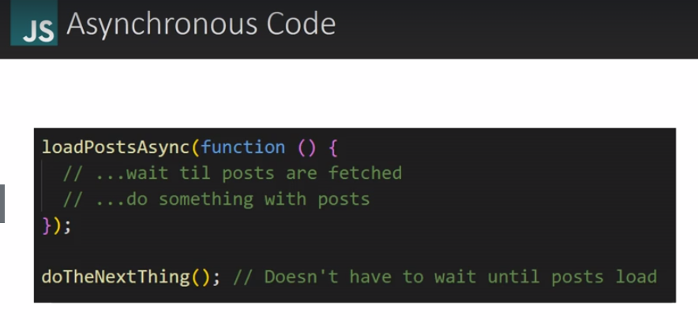

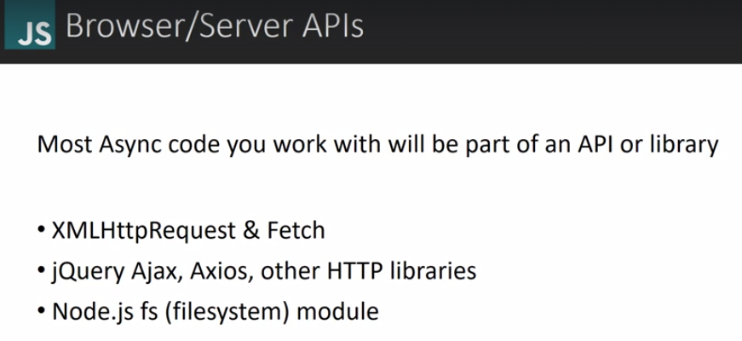

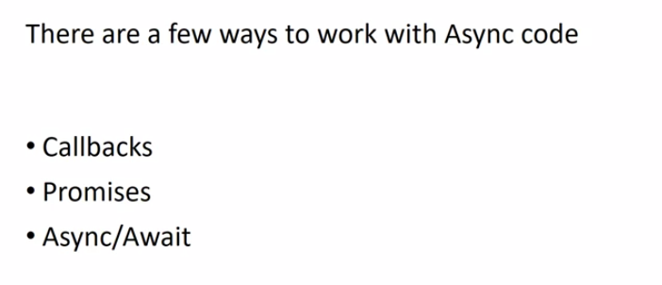

## AJAX & XHR introduction: -

AJAX isn’t a language or a framework or a library. It’s a set of web technology to send and receive data from the client and server. It does this asynchronously, Its done behind the scene without explicitly reload the entire web page.

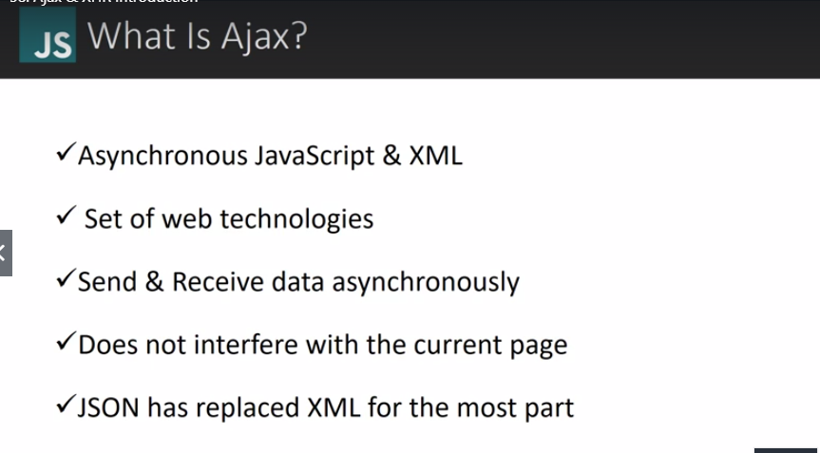

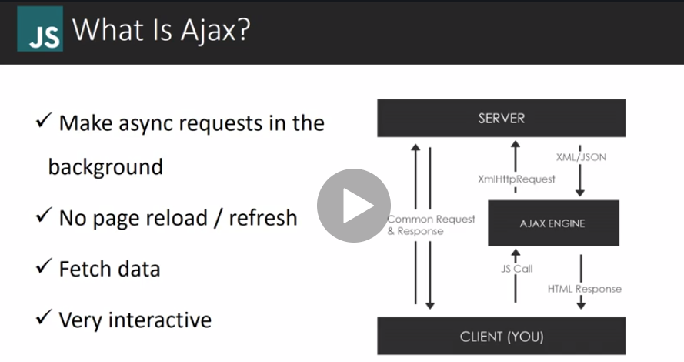

CORE’S ENABLED AND AUTHENTICATION ARE REQUIRED TO ALLOW FOR CROSS-DOMAIN COMMUNICATION.

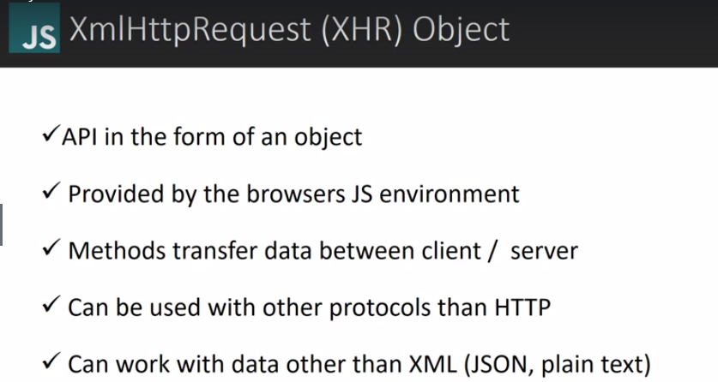

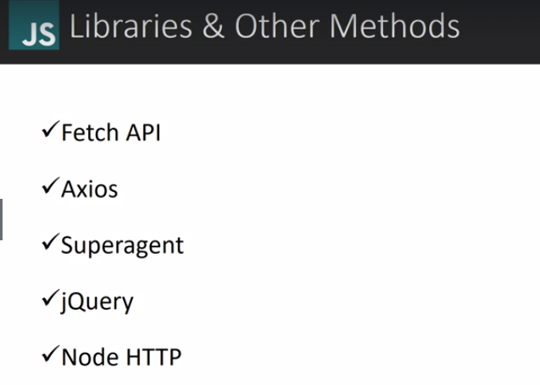

### XHR Object Method and working with test: -

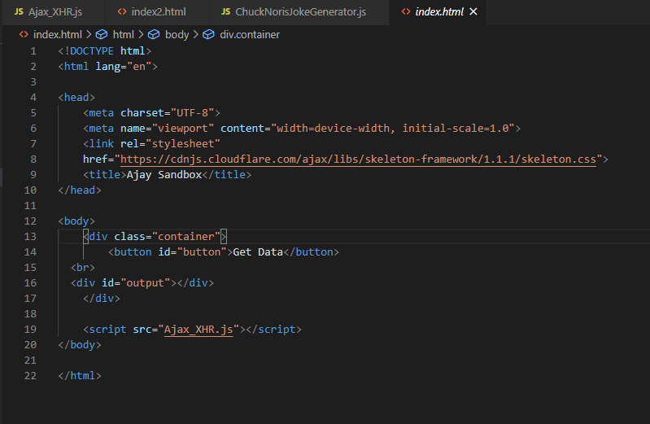

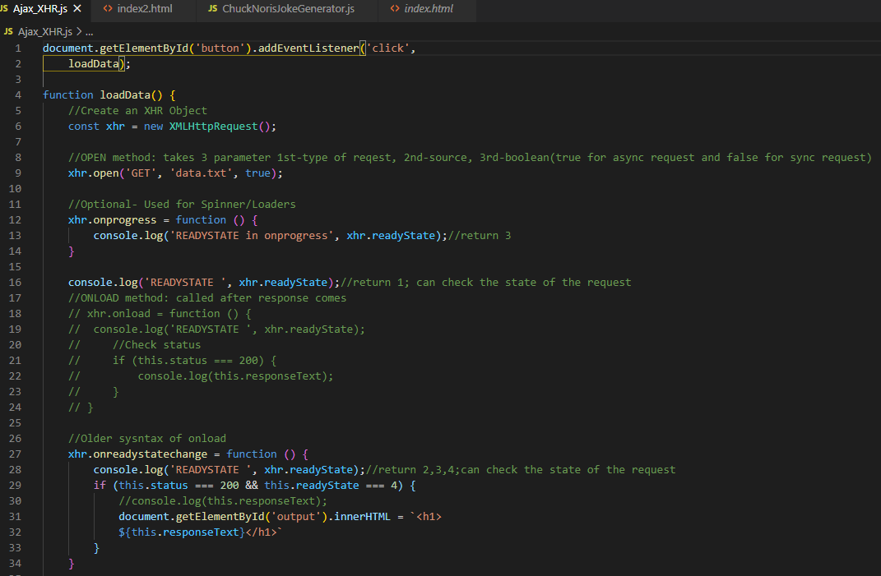

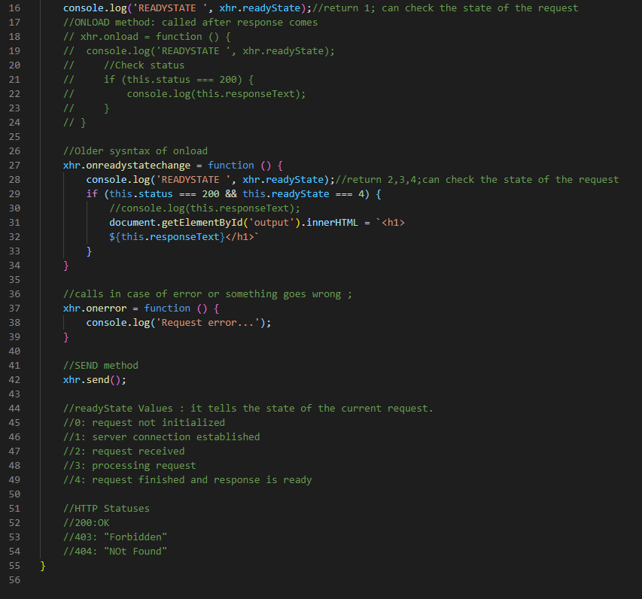

### Working with Ajax and JSON: -

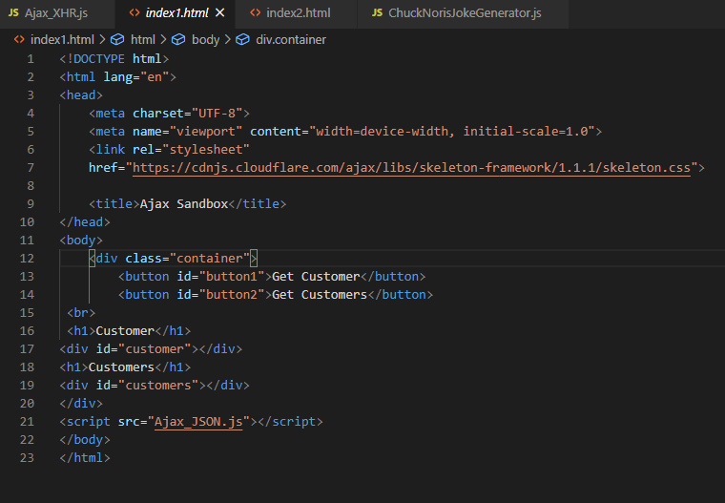

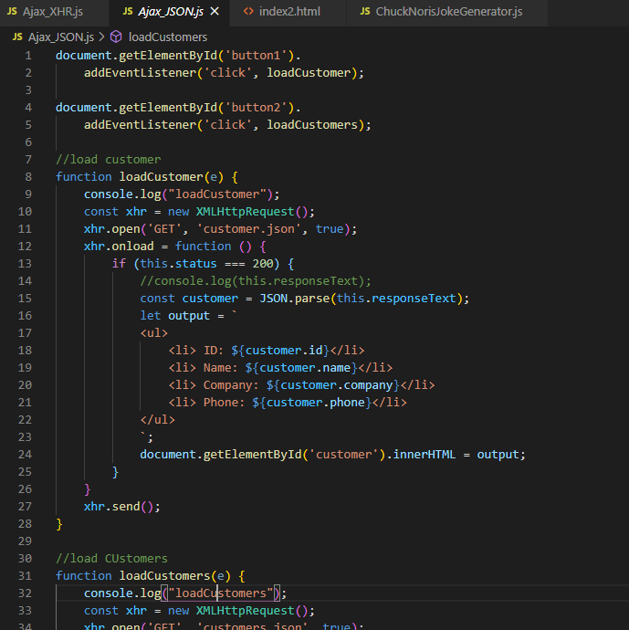

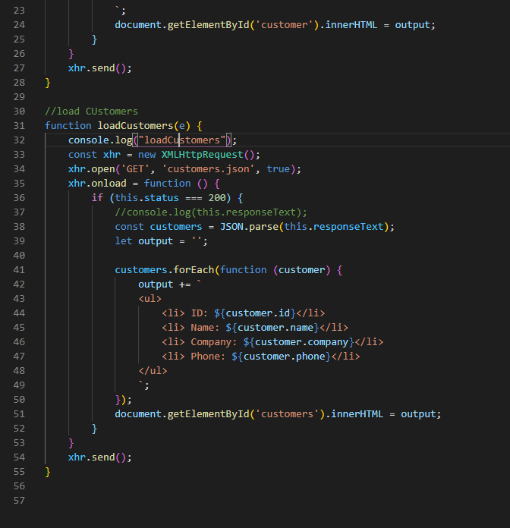

## Data from external API-Chunk Norris Project: -

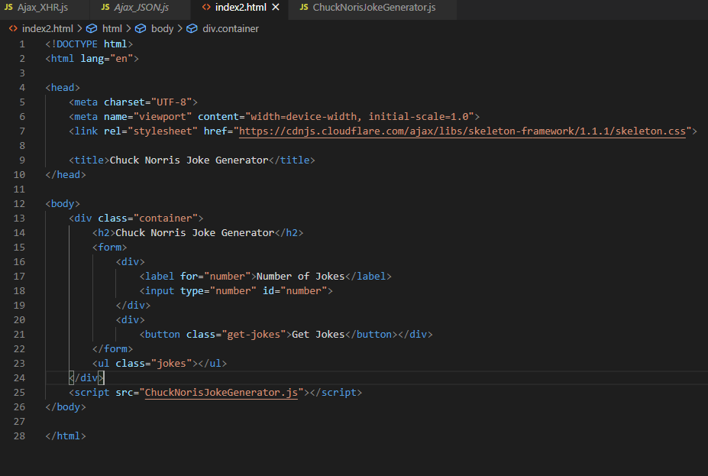

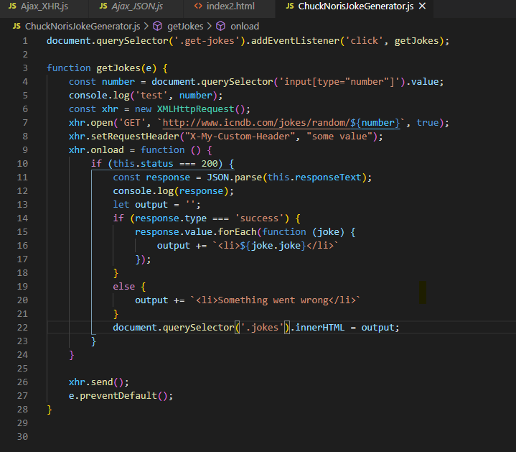

## REST API and HTTP Request: -

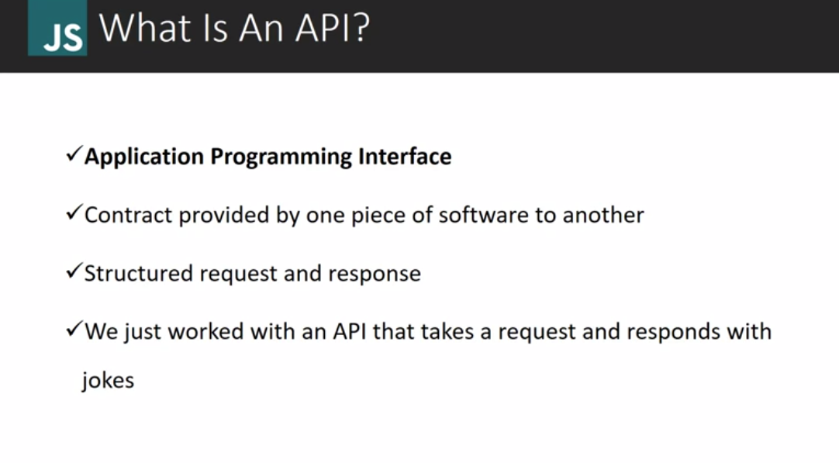

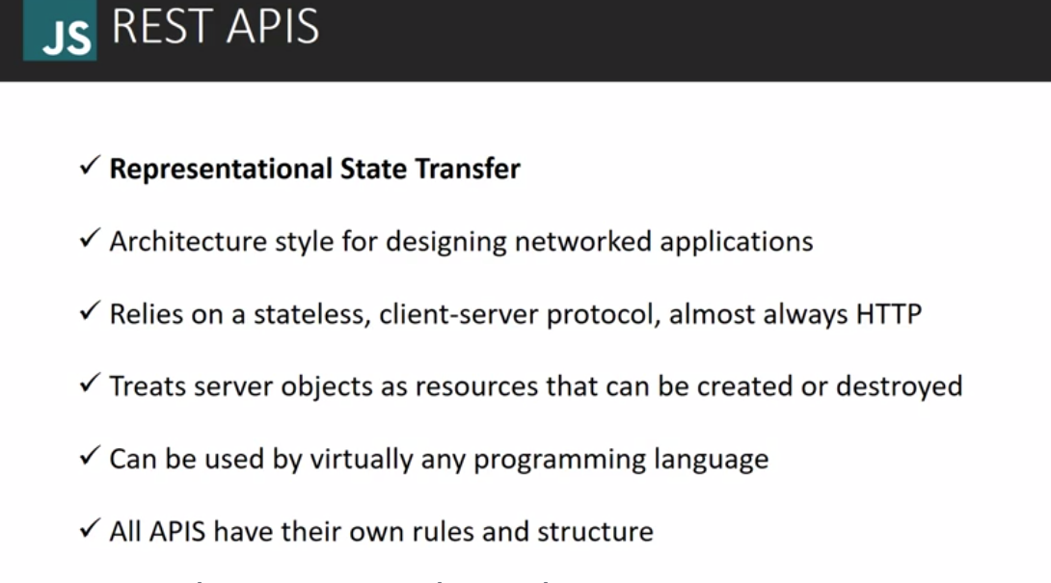

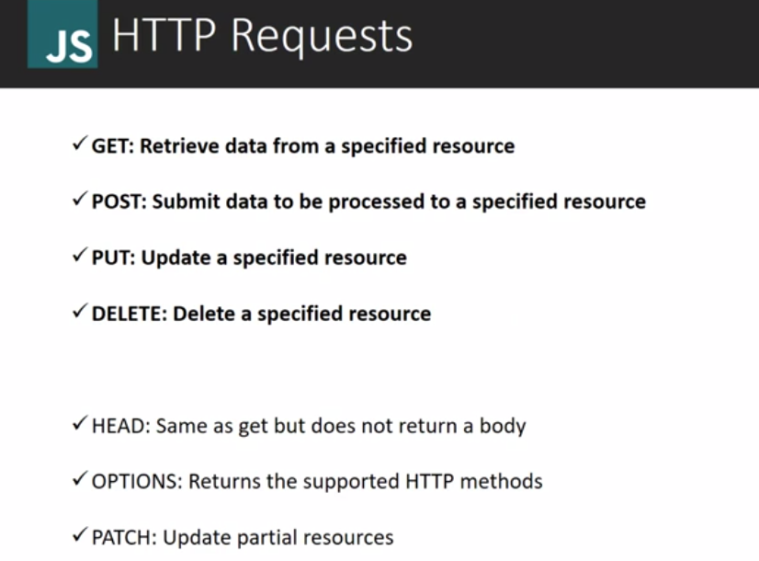

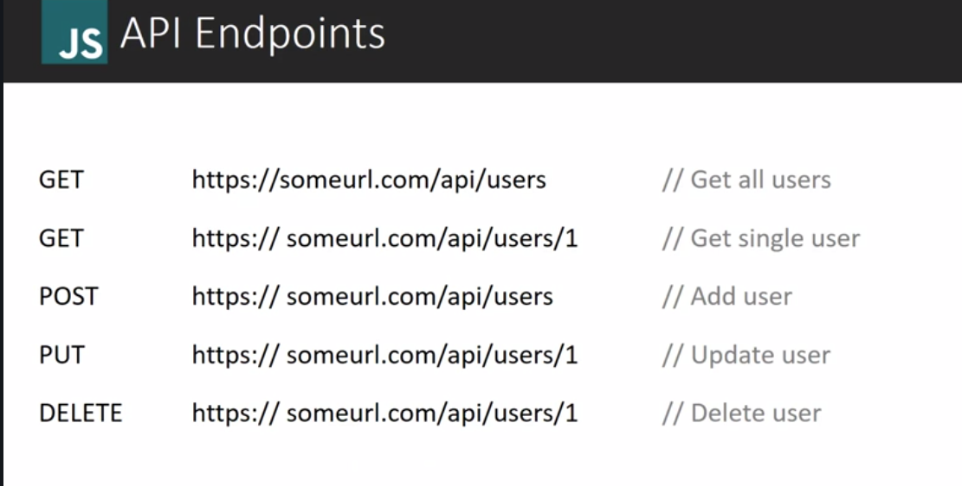

## Callback function: -

Callback is simply a function that is passed in as a parameter to another function and then it ran inside the function body. Two types of callback we have synchronous and asynchronous.

SYNCHRONOUS EXAMPLE:

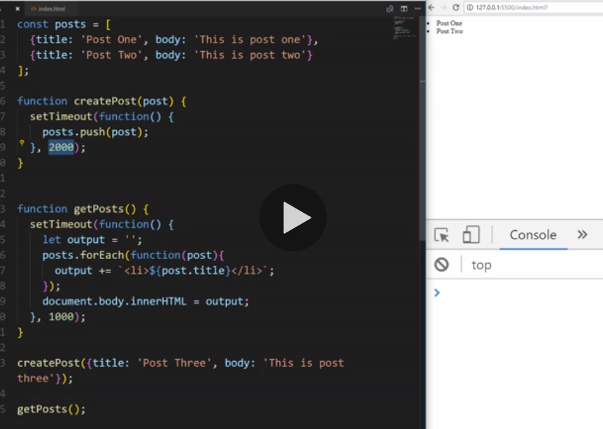

## ASYNCHRONOUS EXAMPLE:

We are passing getPosts method as a callback and it will only execute once createpost completes after 2 seconds.

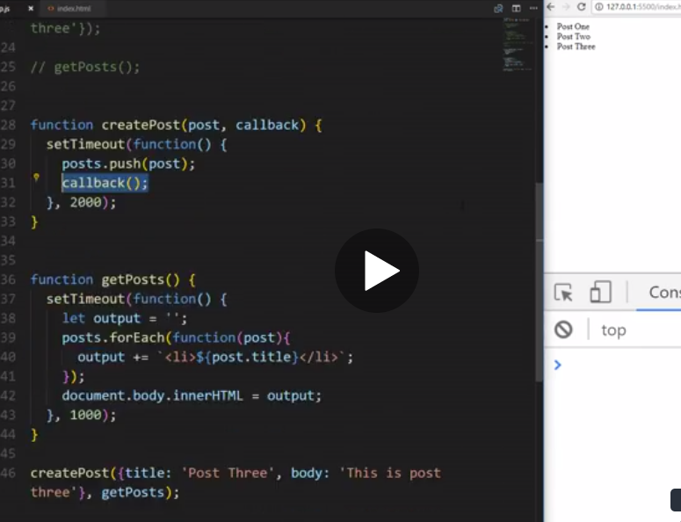

## ES6 Promises: -

Promises is a part of ES6 standard and alternative to callback or an alternative way of handling asynchronous operations.

It is called promises because while they are handling asynchronous operations, they can promise to do something when that operation is finished. And we handle promise response by using ‘**.then**’ .

Promise takes two parameter: 1st parameter- resolve and 2nd parameter- reject.

Resolve() will be called if everything goes well else Reject() will be called.

Used the same example that has discussed in callback function.

Here we have removed 2nd argument callback from createPost method and returning Promise object which takes function having two parameter resolve and reject.

While calling we use ‘.then’ and ‘.catch’ for error.

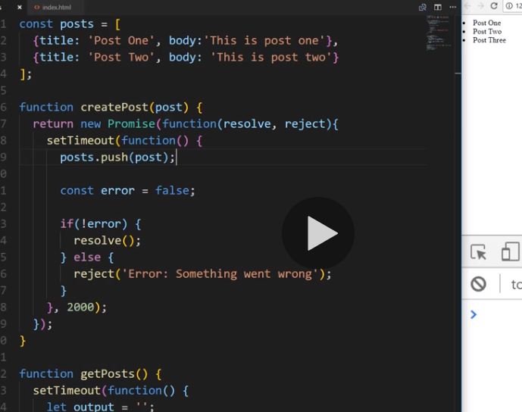

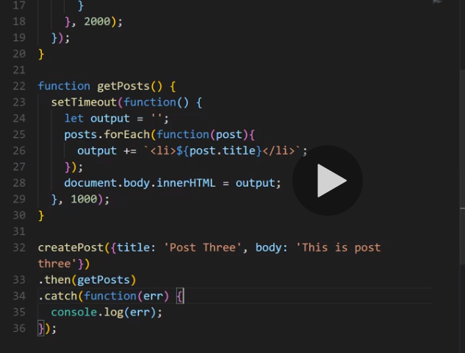

## Fetch API: -

Fetch api is an alternative to AJAX and use to do HTTP request like AJAX and it is a part of window object.

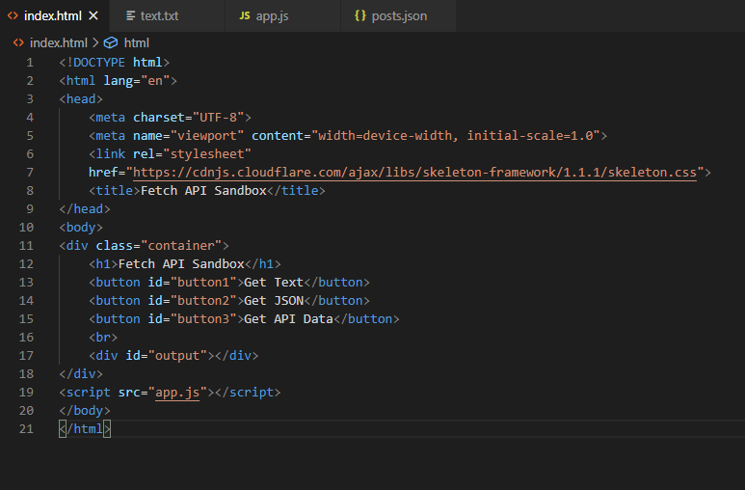

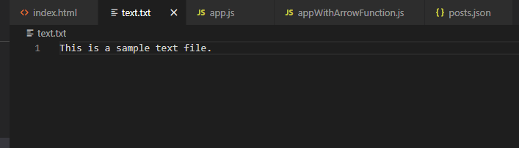

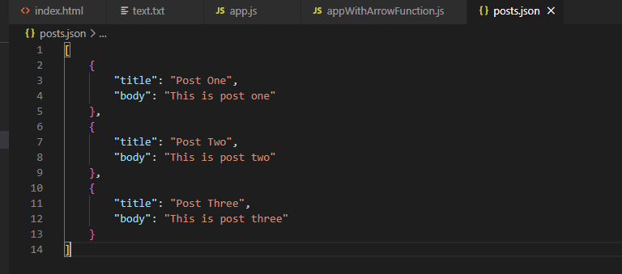

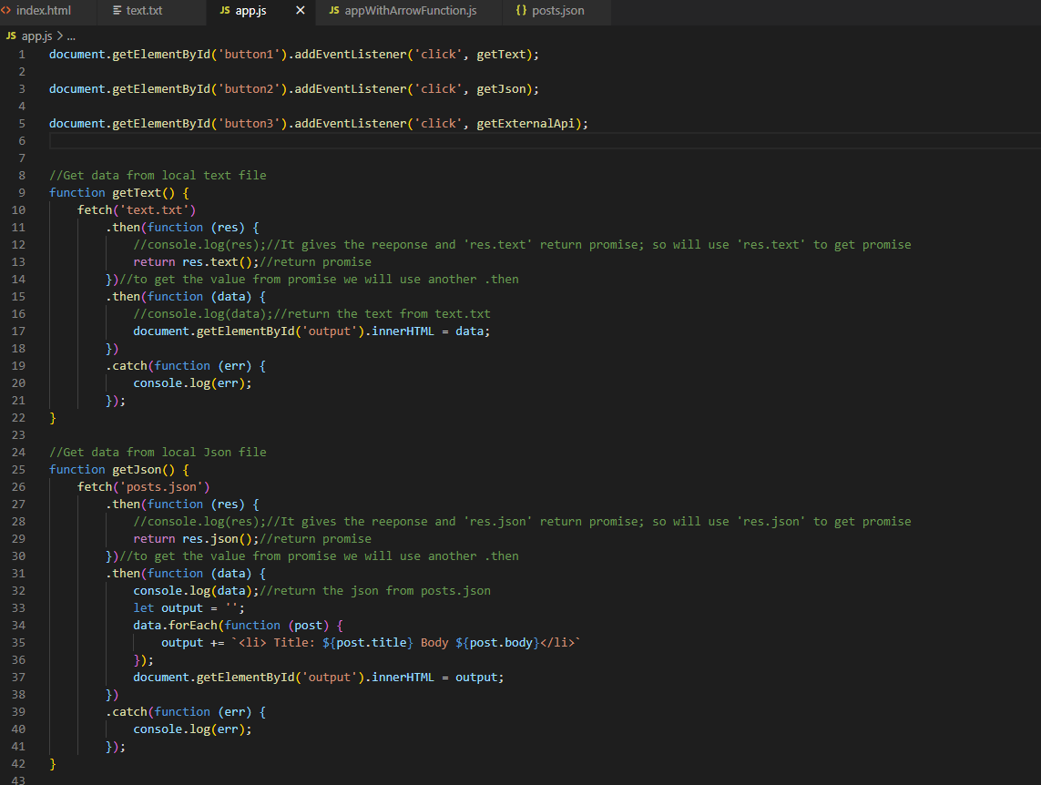

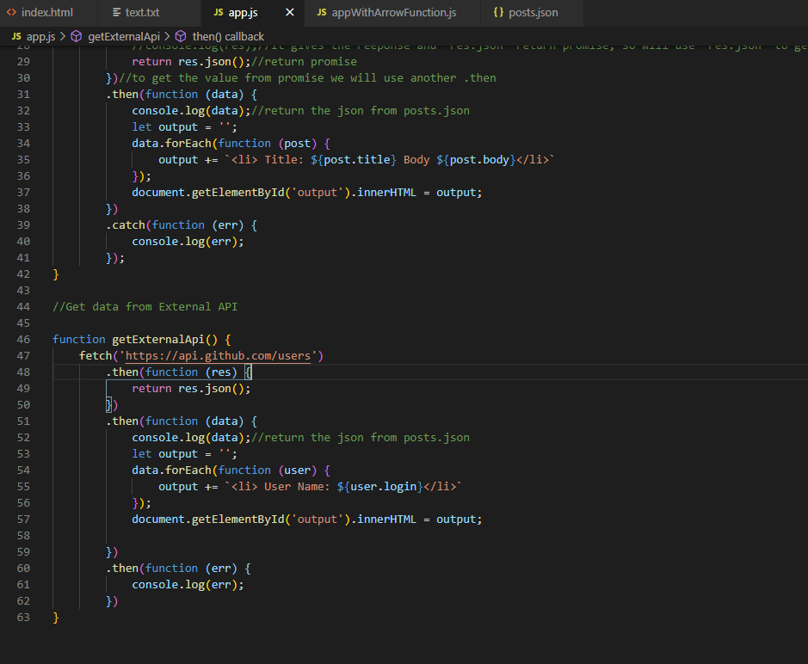

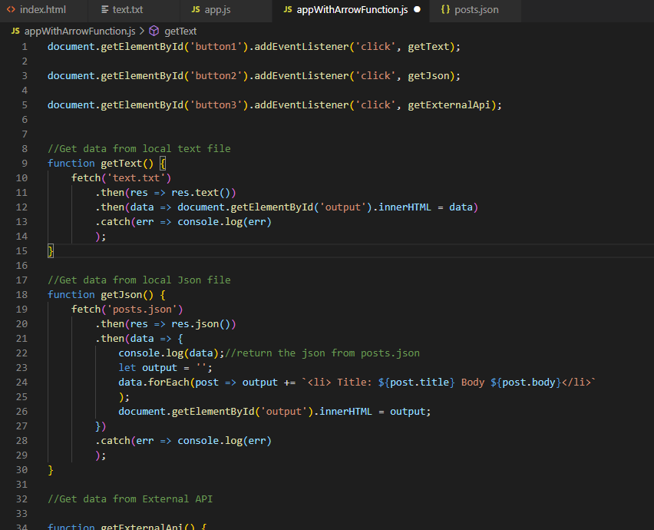

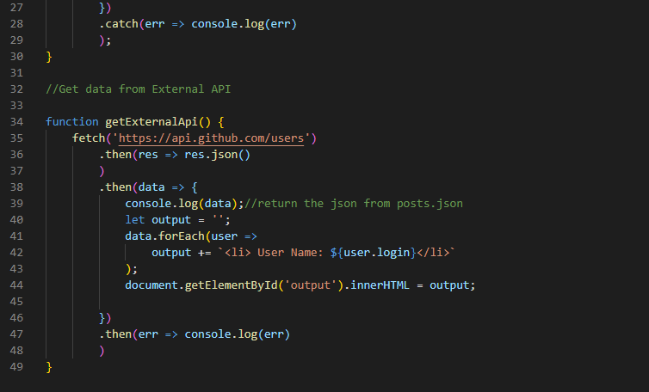

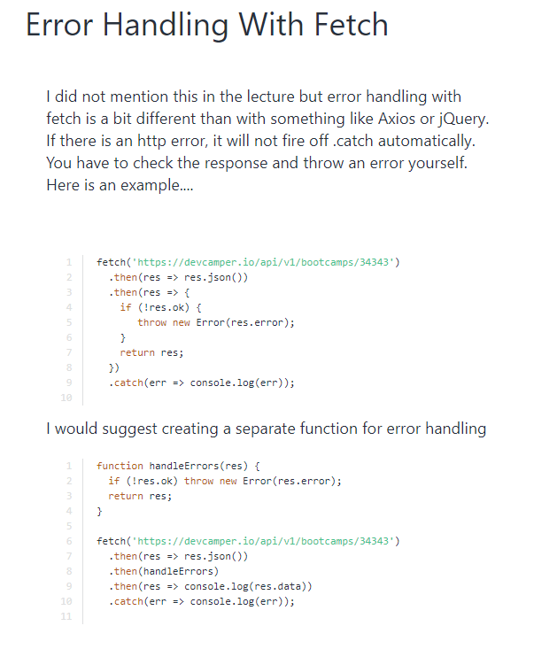

## Arrow Function: -

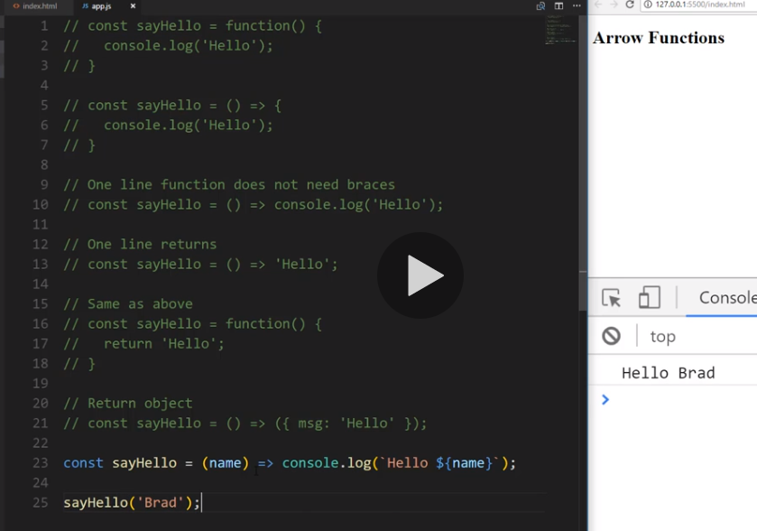

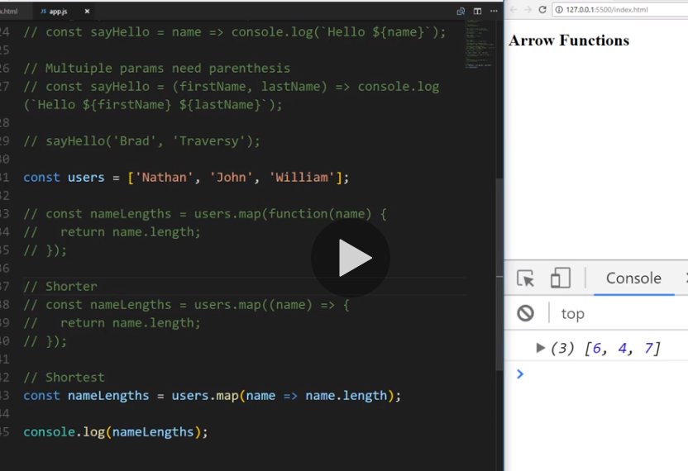

## Custom HTTP Library(Fetch with Promises)- Part 3: -

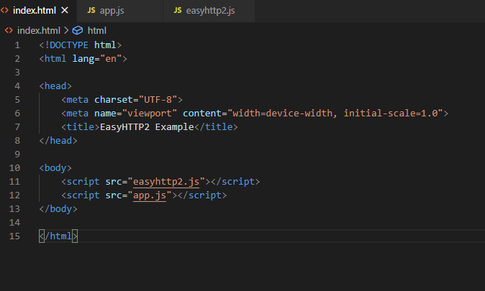

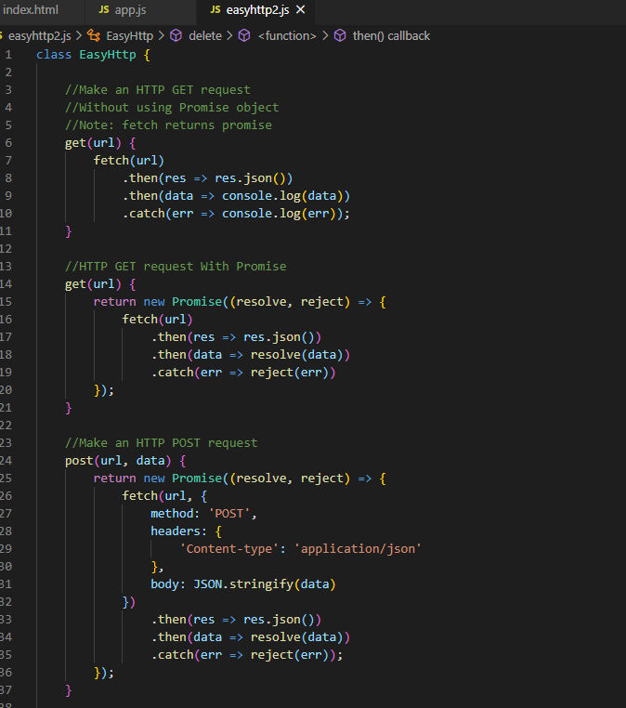

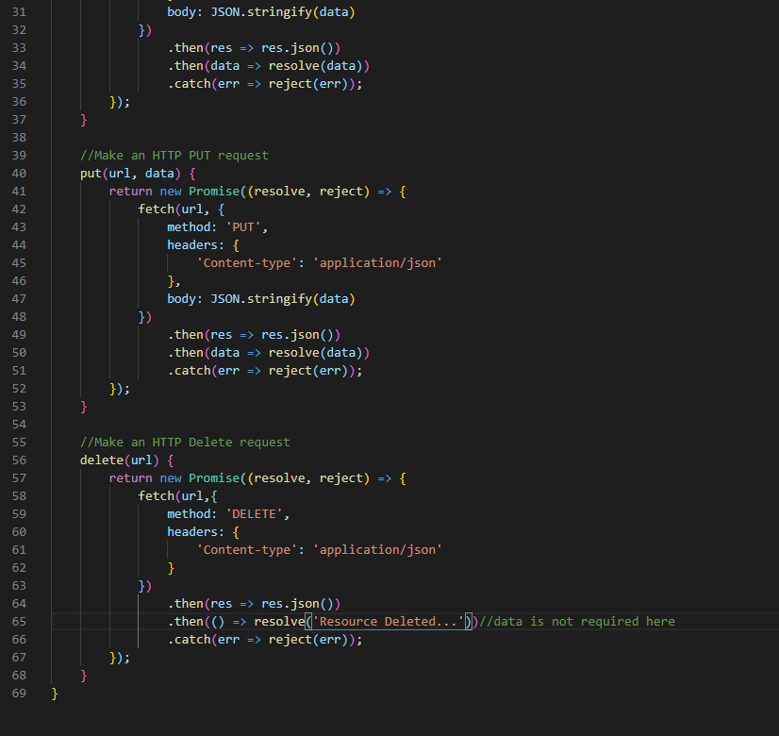

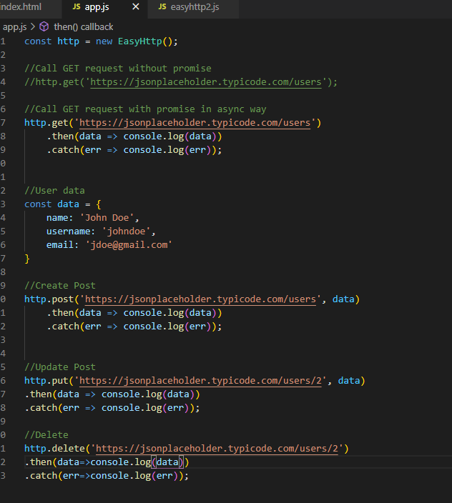

## Async & Await- ES7 Feature: -

It’s alternate way to create promise; like we used to do in ES6 by using new Promise(resolve,reject). By writing asynch in function declaration, function will return Promise.

Await is used with promise and it can wait until promise doesn’t resolve.

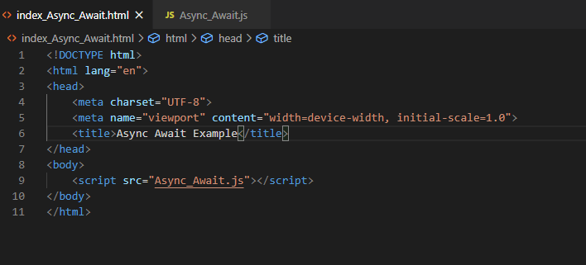

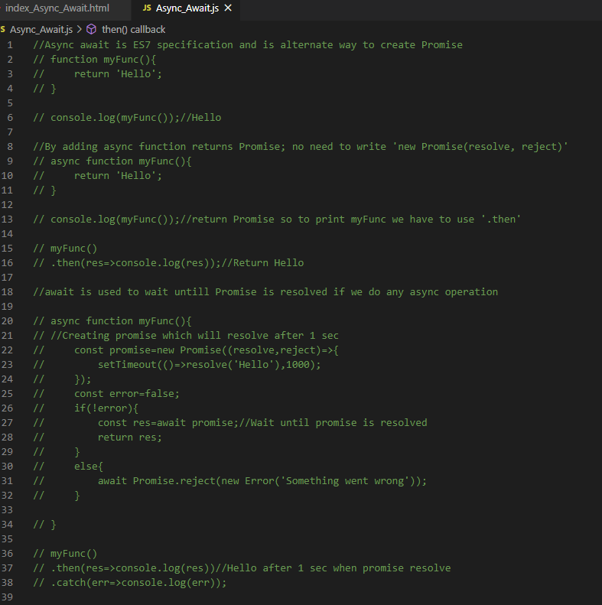

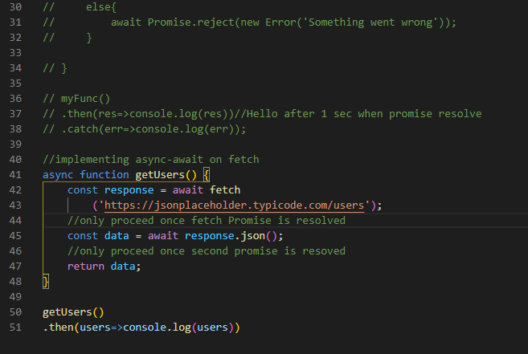

## Error Handling with Try Catch: -

Try andis used to handle error in JS. If there is any error in try block, catch block handles it.

Try-catch can handle error without stopping the entire script i.e our program won’t terminate; the code writer after catch block will be executing.

Finally block always run whether error occurs or not.

Custom error can be throws by using throw keyword.

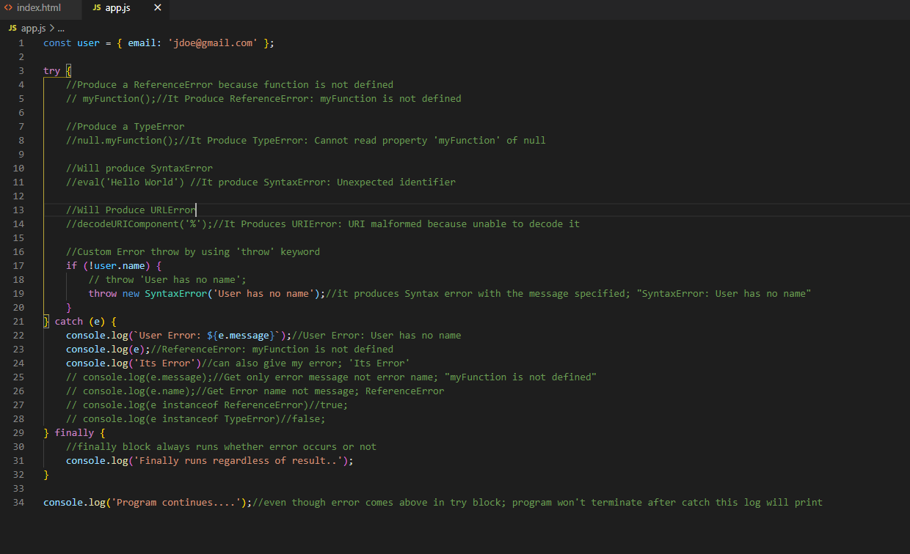

## Regular Expression: -

Regular expression is used to describe a pattern of characters. It’s used for pattern matching, pattern searching, commonly used for validation.

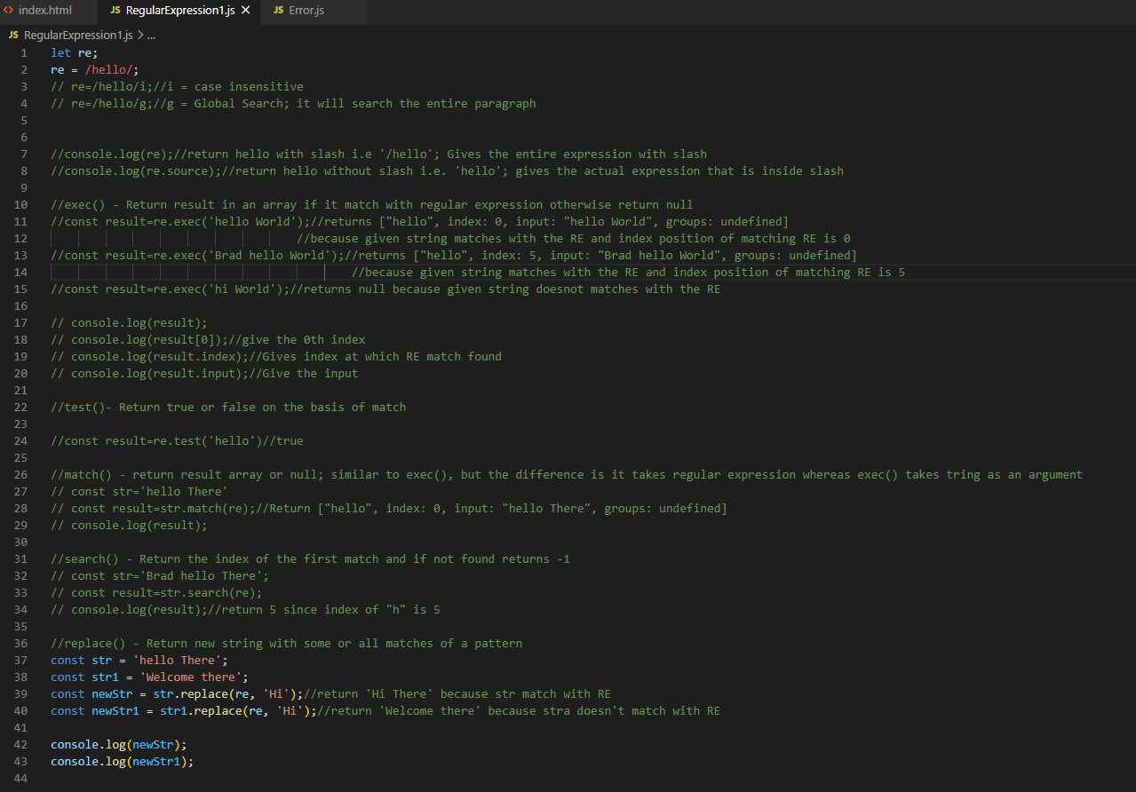

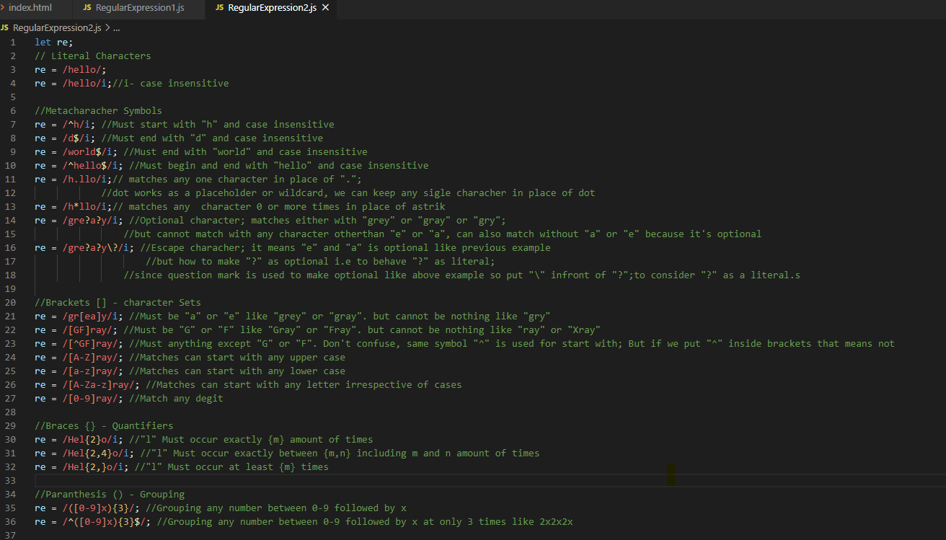

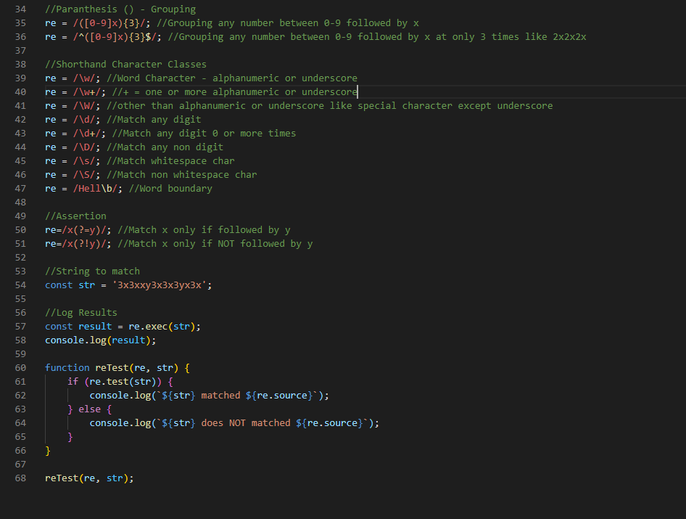

### Form Validation with Regular Expression: -

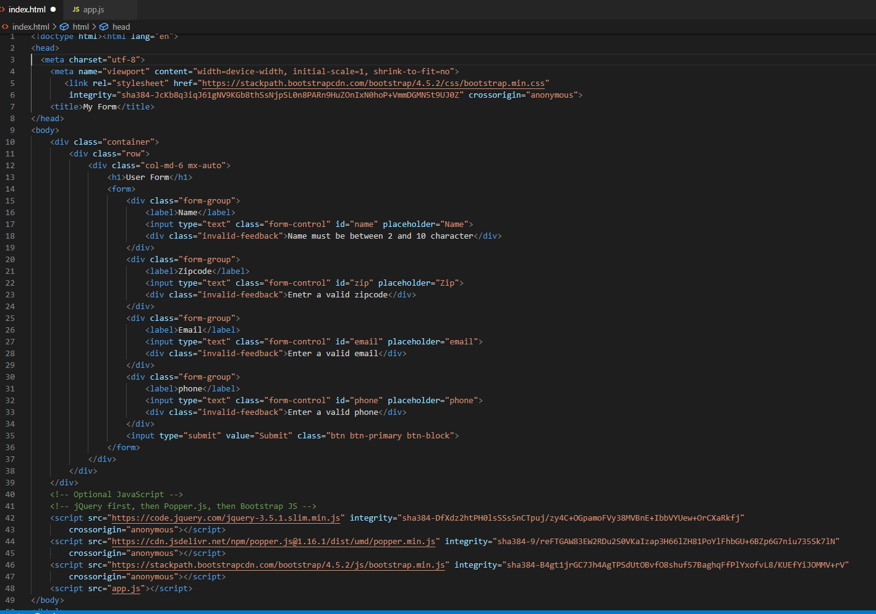

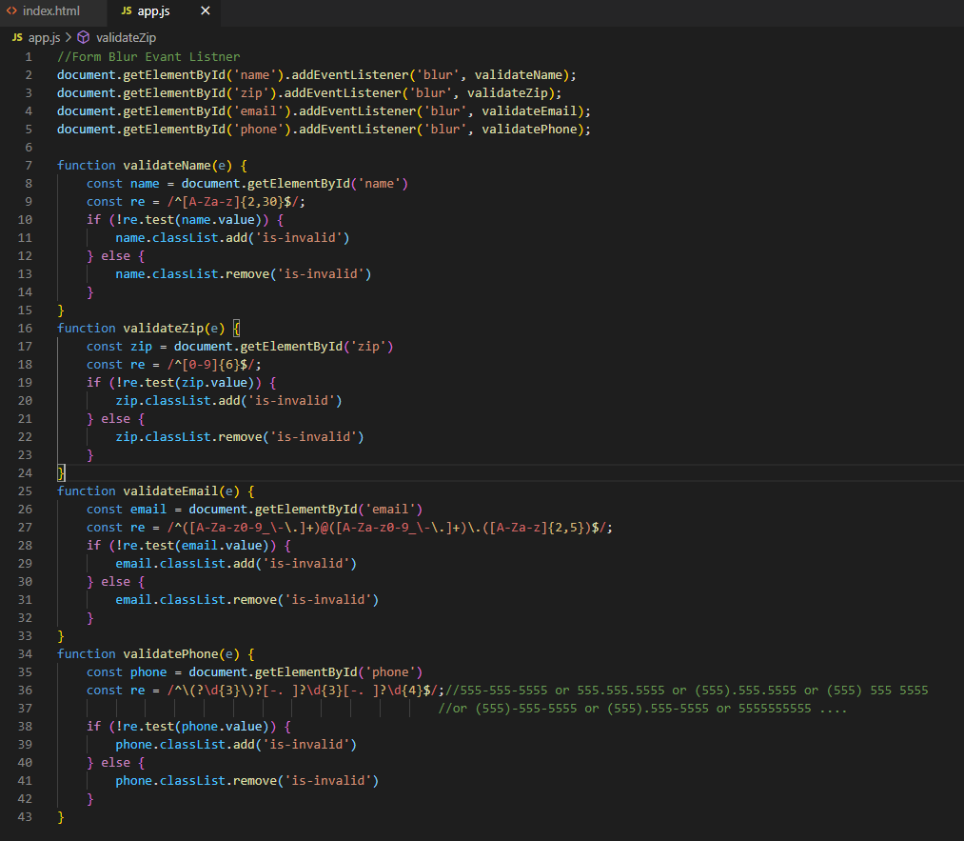

## Iterators and Generators: -

Iterators and Generators both are the part of ES6 standard. Both are different but used in the similar ways to iterate through something.

Iterators are kind of advance loop that can be paused and

Generators or function can be paused and can return multiple values.

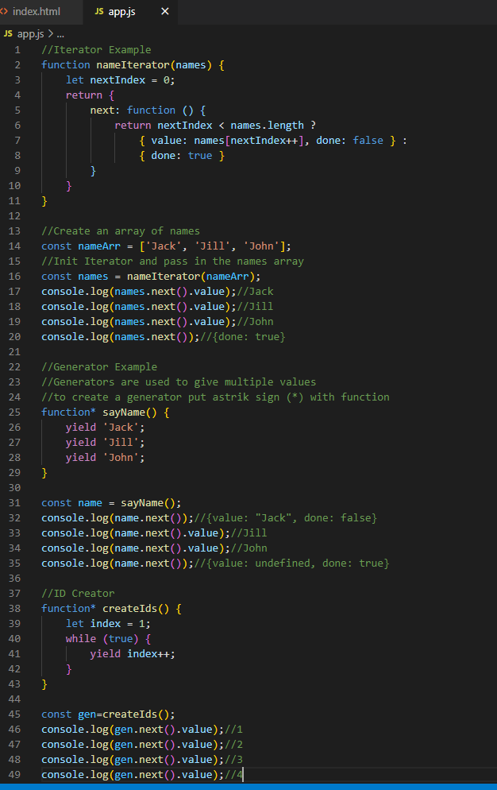

## Symbols(Primitive Data type) in ES6: -

Symbol is a primitive data type and is a part of ES6 standard.

Main property regarding symbols is that event single symbol is completely unique from other symbol.

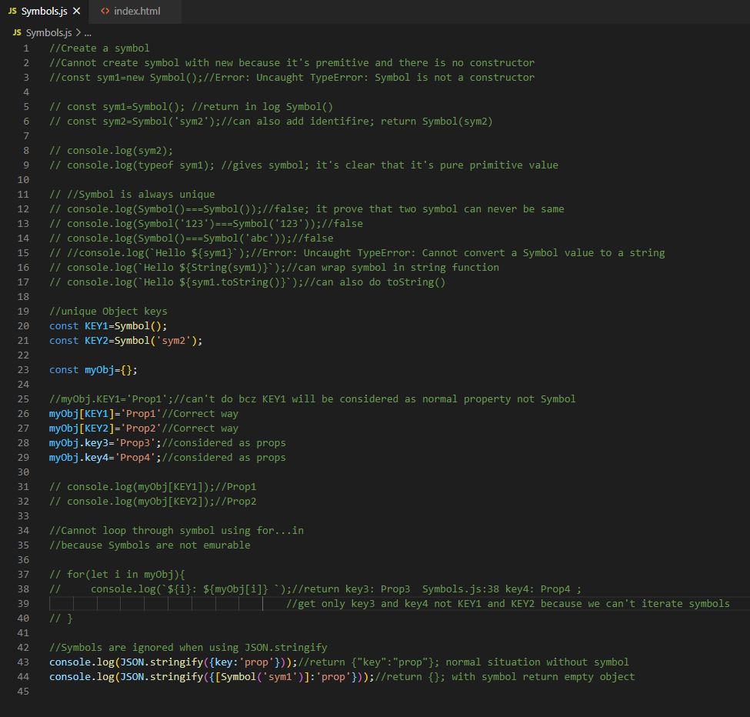

## Destructuring: -

Destructuring was introduced in ES6 and it gives an easy way to assign variables and extract variables from array and objects.

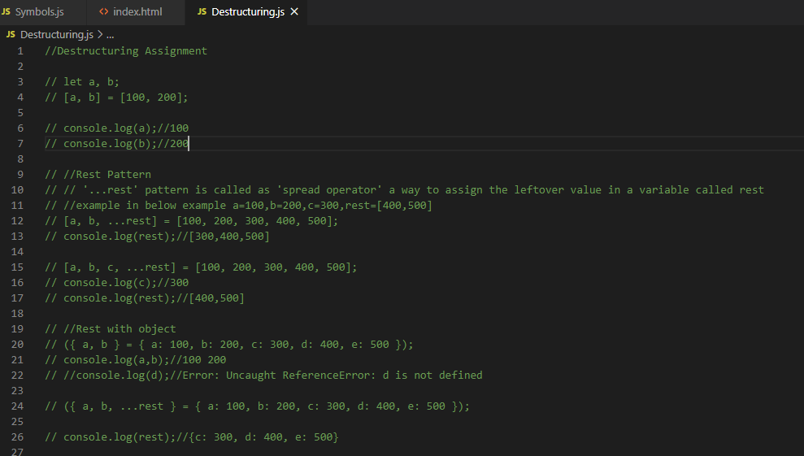

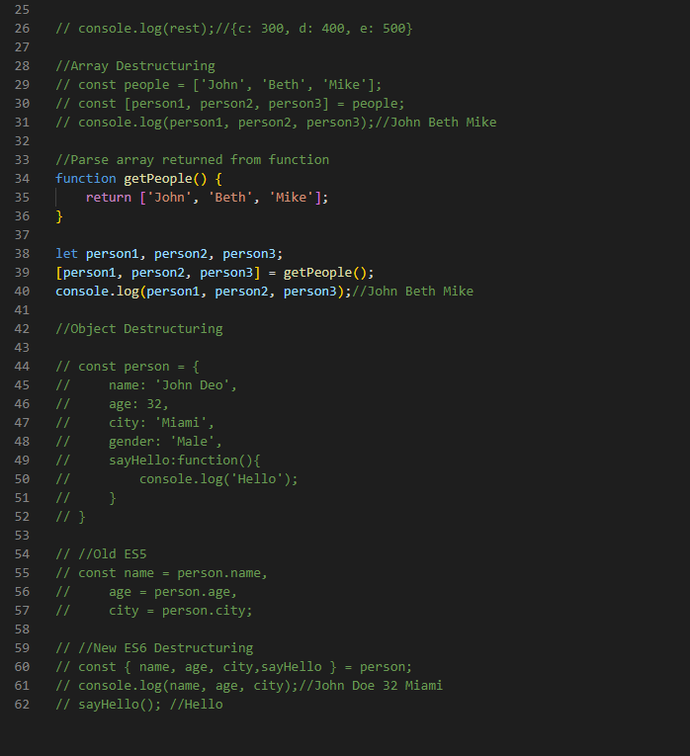

## Map: -

Maps are a new object structure introduced in ES6. A map is an object that holds key value pairs and any value whether it is an object reference type or a primitive can be used as a key or a value which is very different than just an object literal.

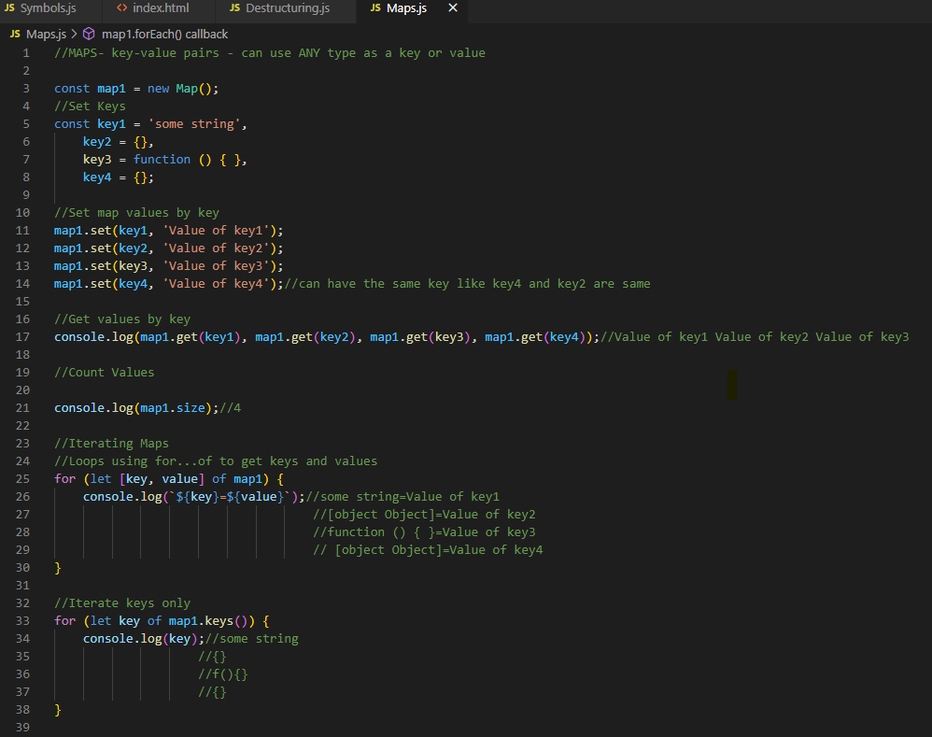

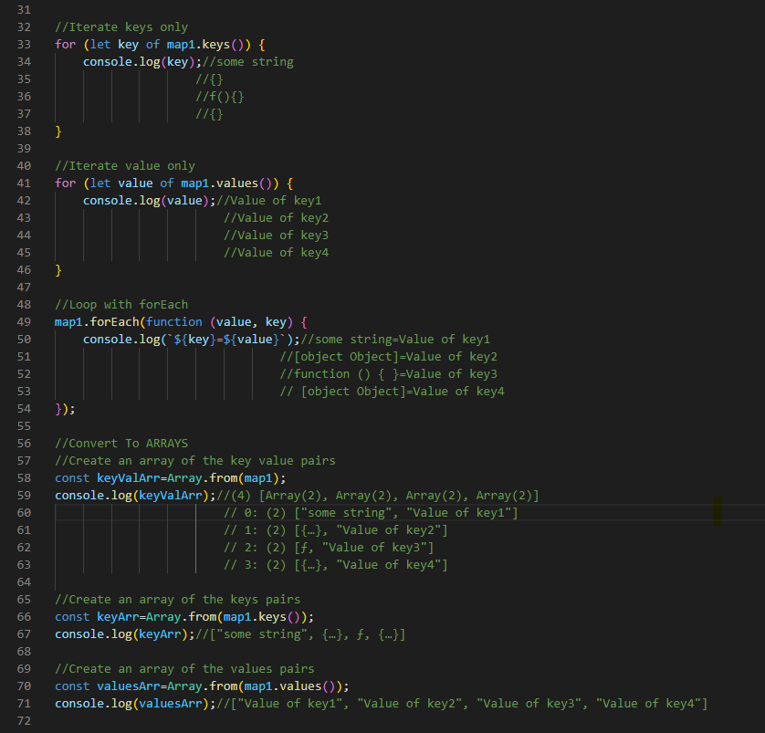

## SET: -

Set is a list of unique value of any type whether it is primitive or reference.

It doesn’t give error If we try to add duplicate value in set but it will not be added.

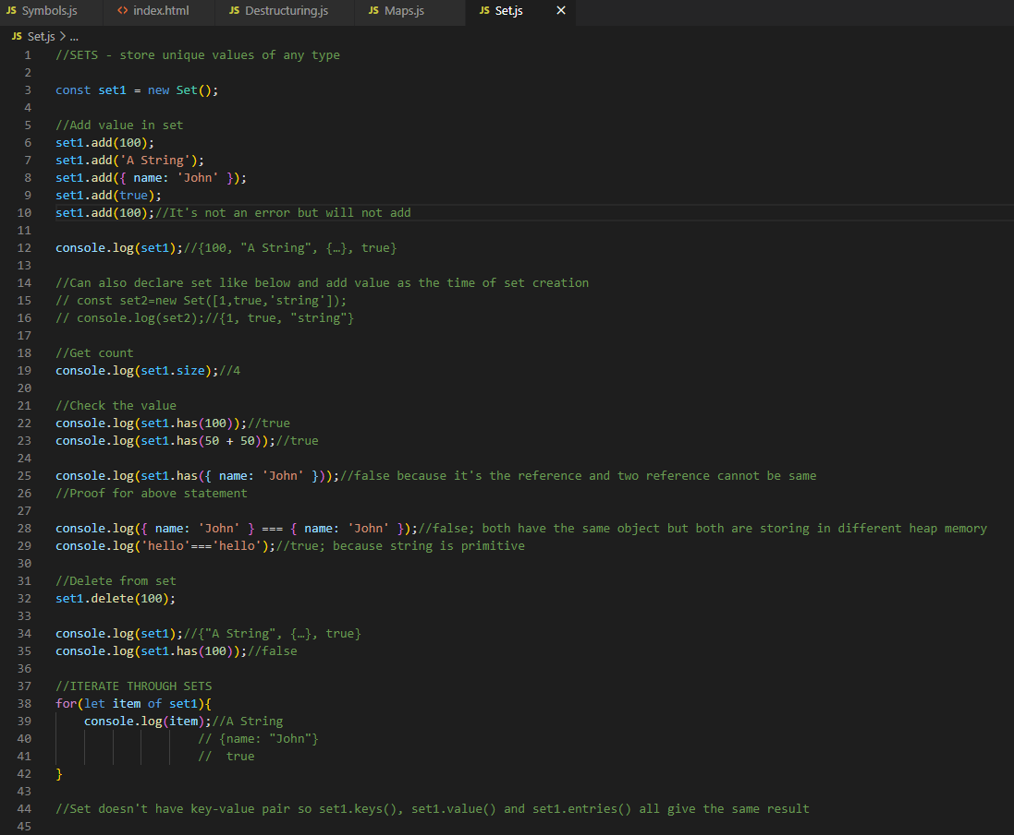

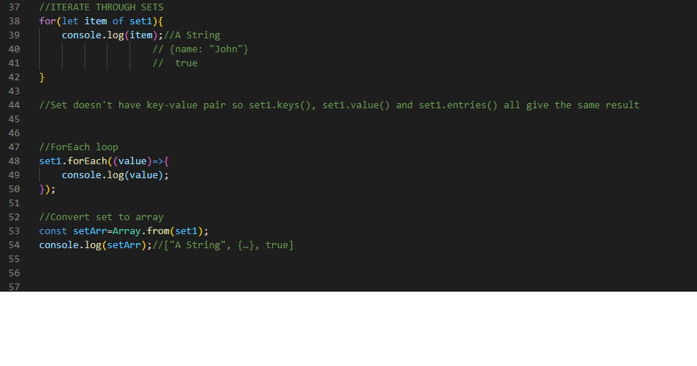

## JavaScript Patterns: -

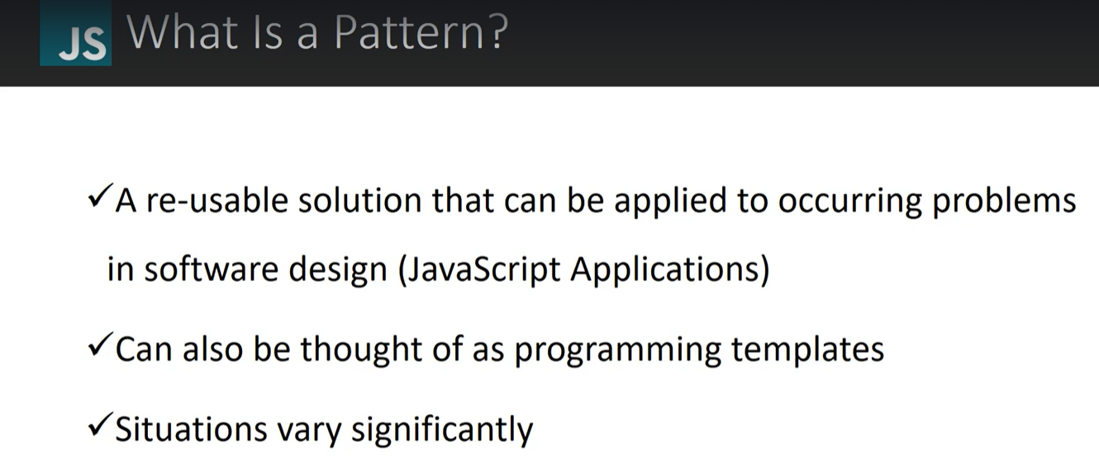

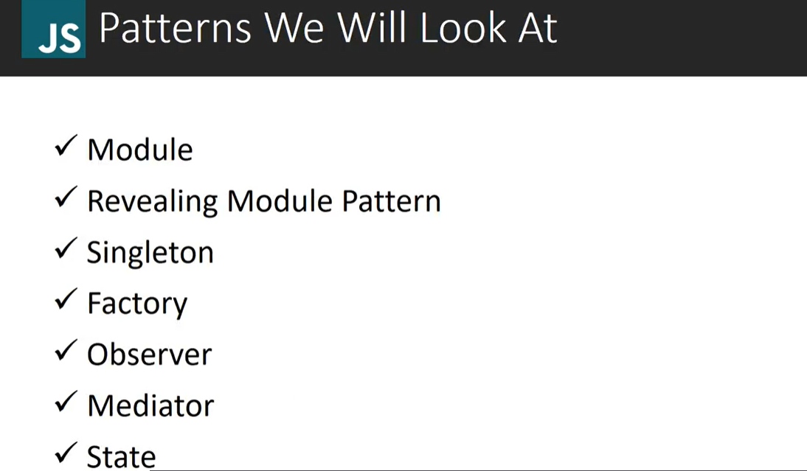

### Module and Revealing Module Pattern: -

In module pattern, programs are divided into small modules having function and variables which are declared to be private and can only be accessed inside return block. Private variables and function are not accessible outside the IIFE.

But the variables and function written inside return block have public scope. Private variable and function can only be accessed by return block function which has public scope.

REVEALLING MODULE PATTERN is similar to module pattern but it can reveal their private variables and function to public level.

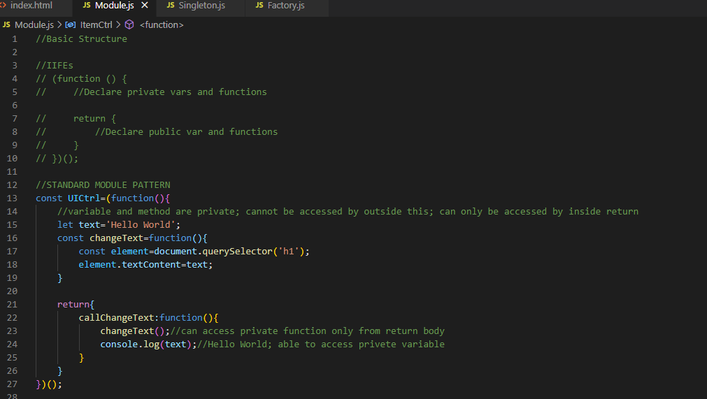

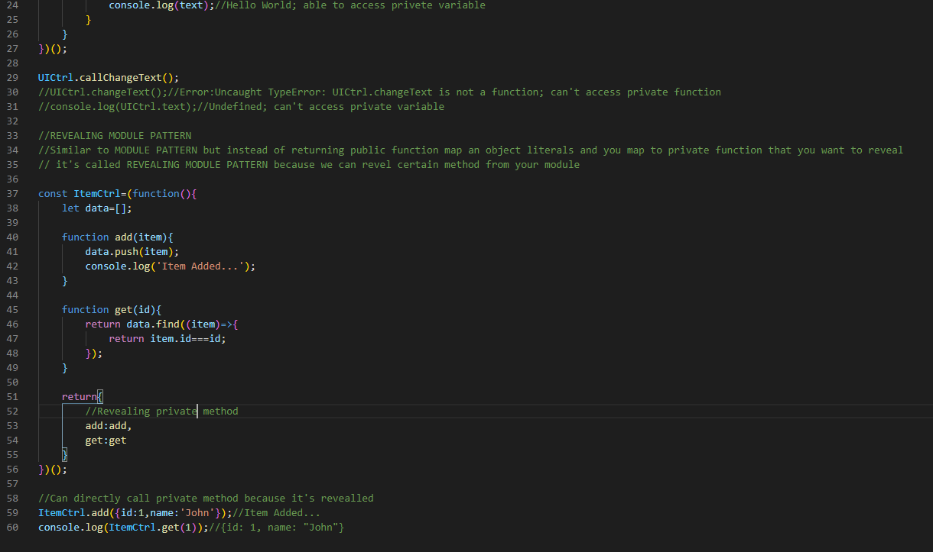

### Singleton Pattern: -

Singleton object is an immediate anonymous function and it can only return one instance of an object at a time.

Repeated calls of the constructor will return the same instance.

like module pattern it maintains a private reference which cannot be accessed from the outside.

use-case: - login user; same user can't login at two place at same time

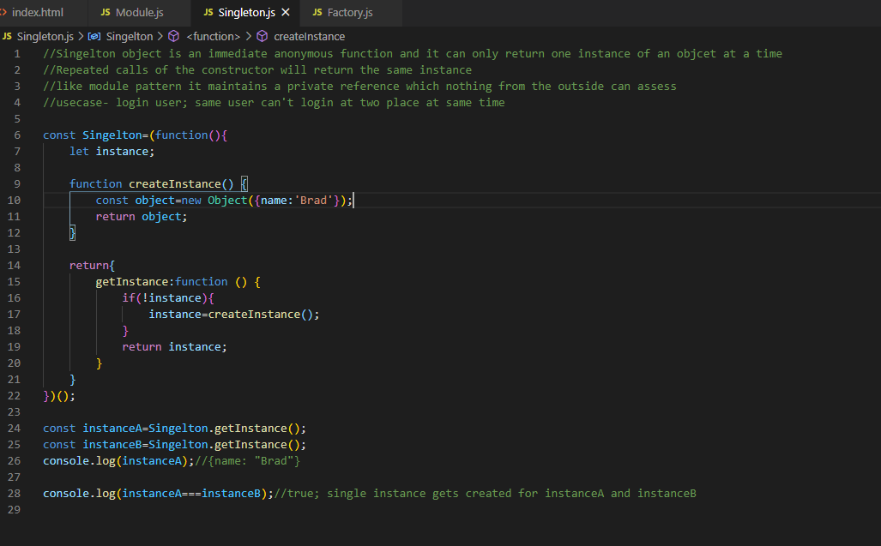

### Factory Pattern: -

Factory pattern also called factory method in JavaScript which is a way of creating an interface for creating object but we can let subclasses define which classes to instantiate and factory methods are often used in applications to manage, maintain and manipulate collections of object that are different. But at the same time have many common characteristics.

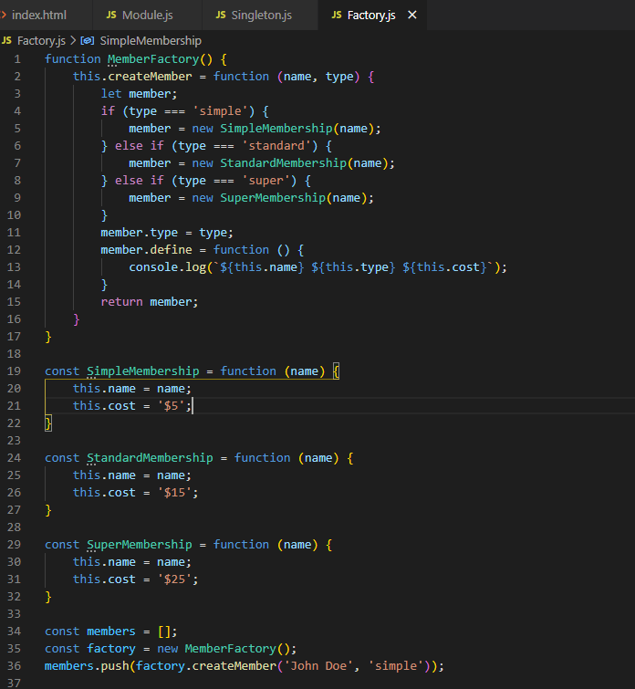

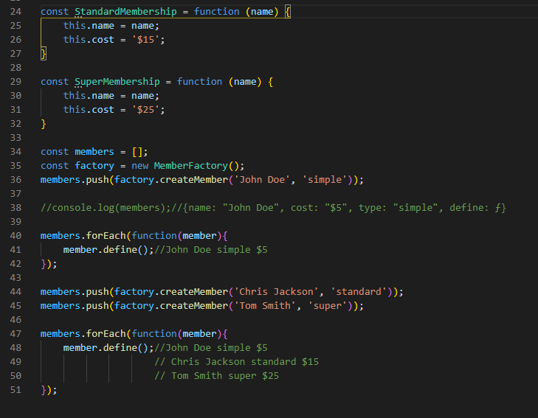

### Observer Pattern: -

Observer pattern allows you to subscribe and unsubscribe to certain events or certain functionality. It gives a nice subscription model. It can be used to notify the DOM of certain elements to be updated.

Angular JS mostly works on this pattern through event management within the scope.

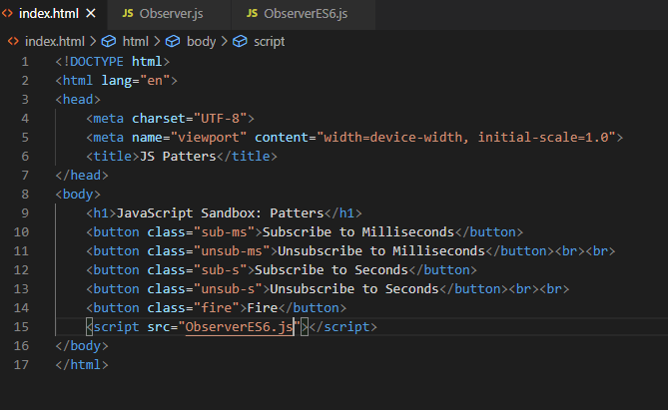

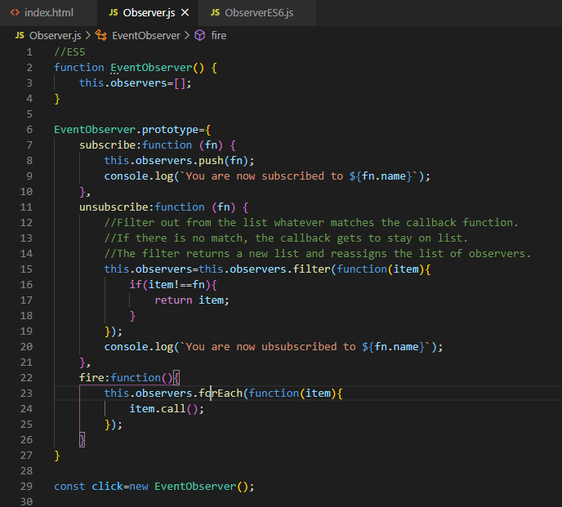

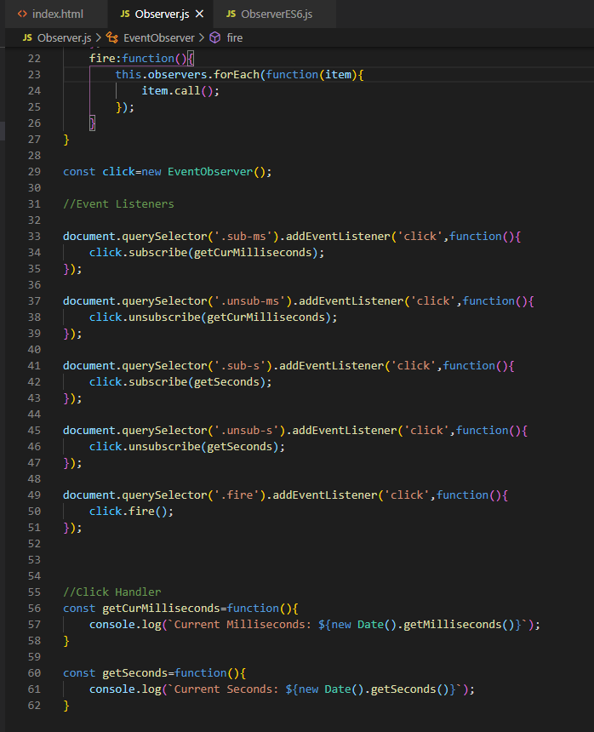

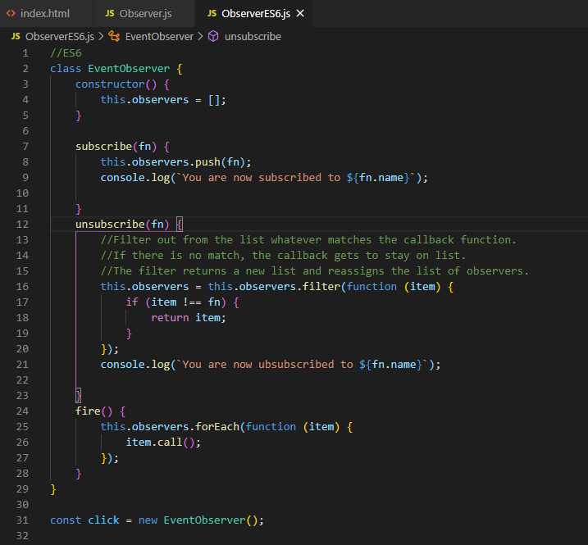

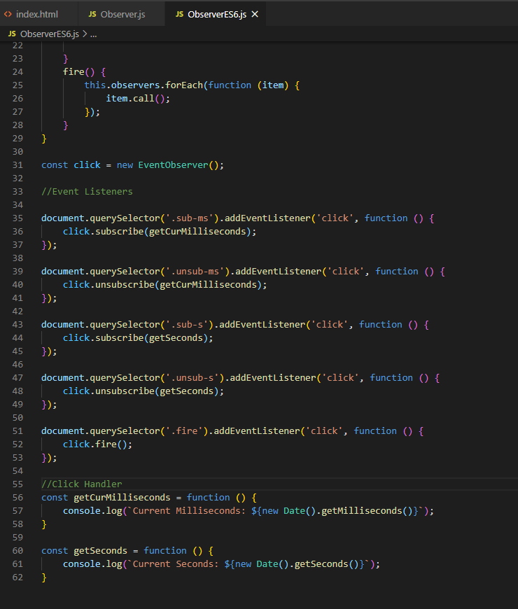

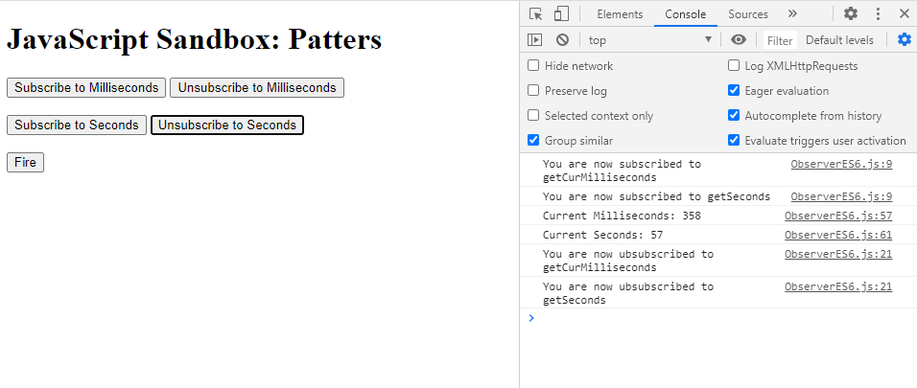

### Mediator Pattern: -

Mediator pattern is another behavioral pattern like observer pattern. The idea is to have a mediator which is basically an interface for communication with what are called COLLEAGUES which are just mediated objects.

Best example of this patter is a chat room.

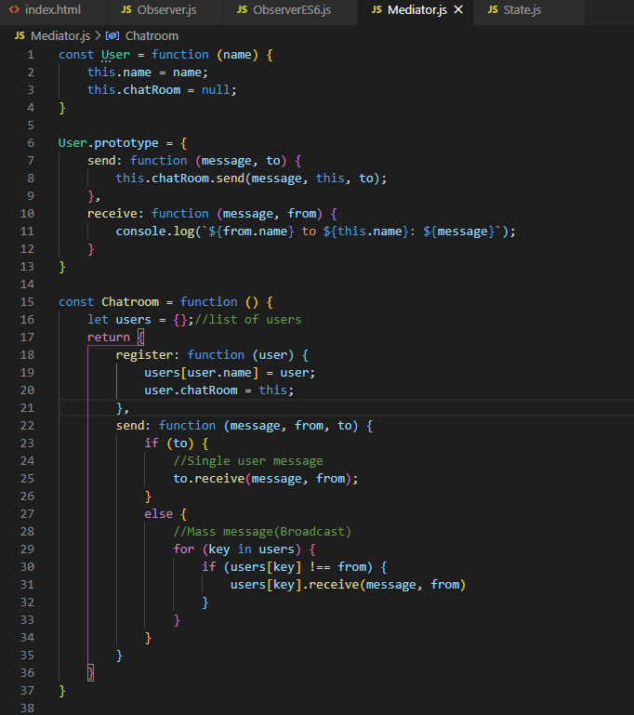

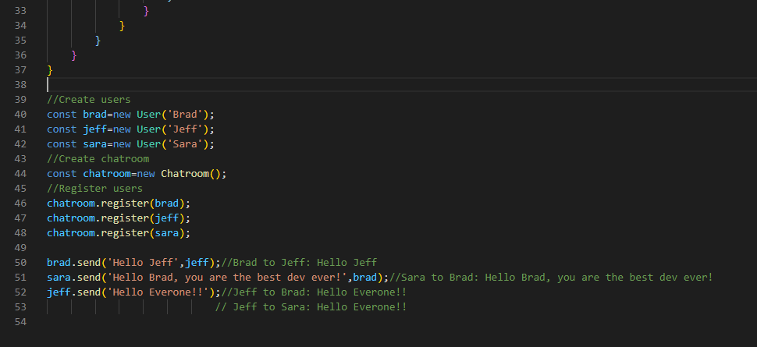

### State Pattern: -

State pattern is another behavioral type pattern. It manages the sate like redux. We have a state that we can change it throughout our script so if we want to do certain things on certain state or display certain content then we can do it.

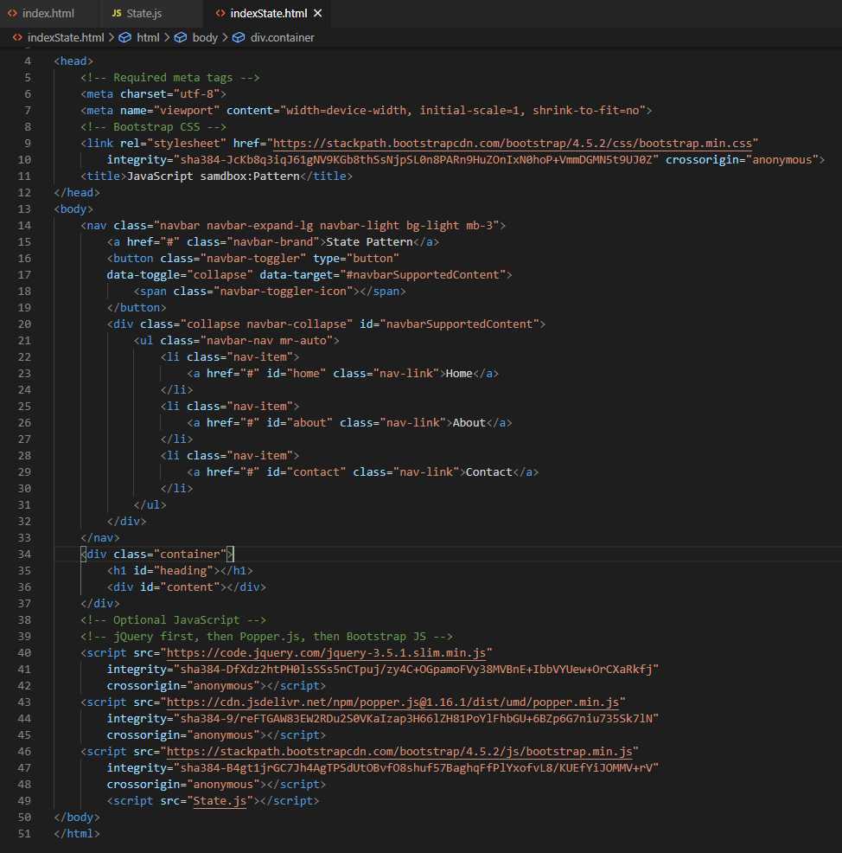

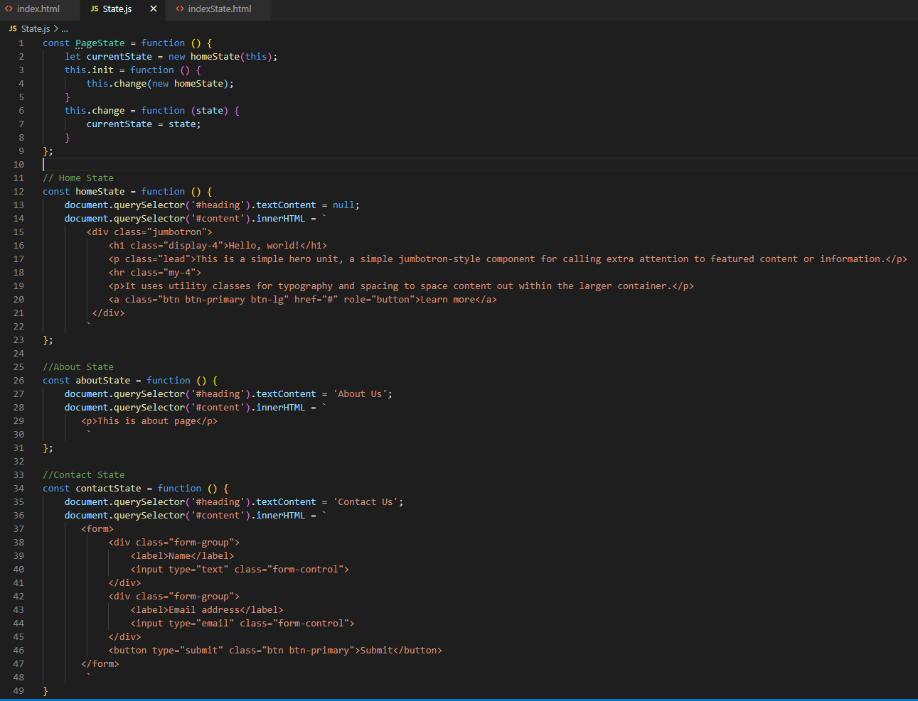

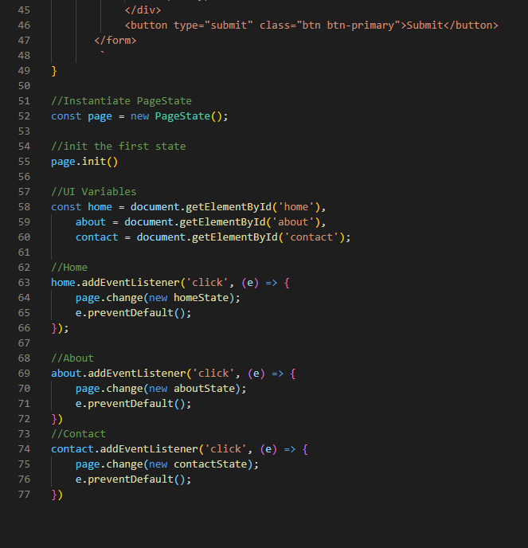

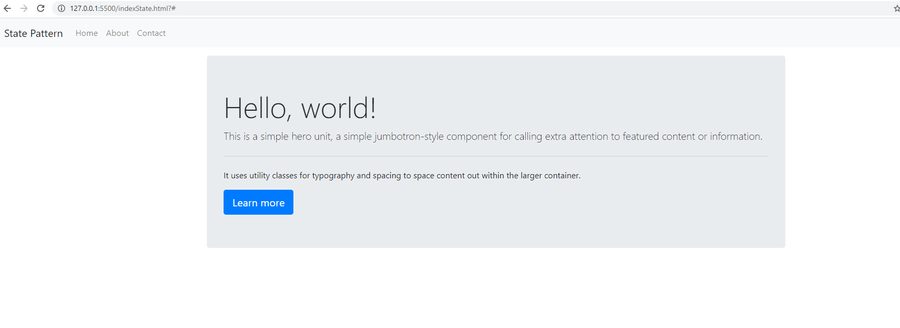

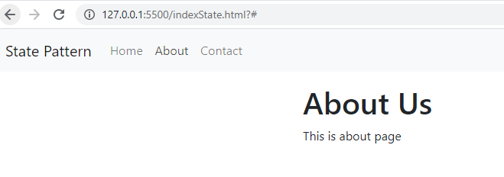

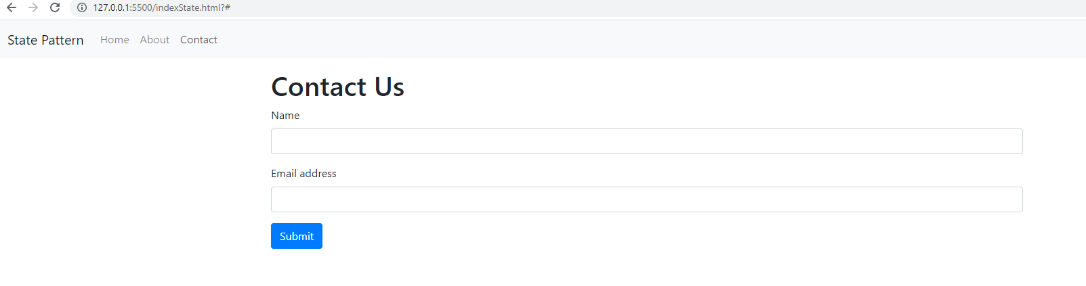

## ES2015 Modules: -

